Detail Design Document
Template V0.1
18 August 2026
Project Name: | Standard User SOE on Azure Virtual Desktop
Document Owner: | Shaun Struik
Contact Details: | shaun.struik@apm.net.au
Program Name: | AVD/Nerdio Implementation
Division/Unit: | Digital Workplace
Document Status: | Draft - for review
Document Version: | V1.0
Product ID: | N/A

FOR INTERNAL USE ONLY
Commercial in confidence
© APM

Document control
Version History
Version | Date | Author | Key changes
V1.0 | 14/08/2026 | Shaun Struik | Initial detail design for the Standard User SOE on Azure Virtual Desktop

Consultation
Name | Position title | Date

References and Derivation
Version # | Document Title | Reference Location

SDA Approval
Name | Role/Group | Signature | Date

Confidentiality & Disclaimer
This document is provided by Advanced Personnel Management International Pty Ltd and / or its related entities (APM) on a confidential basis. This document is subject to approval of the APM Board and does not constitute an offer capable of acceptance. No agreement binding APM or its related companies in respect of this document is intended or proposed unless and until the terms and conditions between APM or its related entities are agreed in writing in a formal agreement with the named Company or Prospective Client.
APM will not be bound by any pricing or any other material contained in this response until the above has taken place.
Photography
Photographs used in this document are for illustration only
and should not be interpreted to mean that any person or organisation whose assets are shown in them endorses this document.
APM Contact
Communications regarding
this document should be forwarded to:
Head of Digital Transformation & Architecture
P 08 XXXX XXXX
M 08 XXXX XXXX
E samit.chandra@apm.net.au

Contents
1. Introduction 6
1.1 Purpose 6
1.2 Audience 6
2. Overview 7
2.1 Scope 7
2.2 Guiding Principles 7
2.3 Assumptions 7
3. Business Architecture 8
3.1 Business Reference architecture 8
3.2 Business Requirements 9
3.3 Gap treatment 9
4. Application Architecture 9
4.1 System Context Diagram 10
4.2 Solution/Product Component Inventory 10
4.3 Solution Interface Diagram 10
4.4 Solution/Product Interface catalogue 10
5. Technology Architecture 10
5.1 Technology Component Standards 11
5.2 Integration standards and patterns 11
5.3 Network & Infrastructure Standards & Patterns 12
5.4 Technology component Deployment Patterns 12
6. Information & Data Architecture 12
6.1 Information Model 12
6.2 Information Classification 13
6.3 Analytics and reporting Patterns 13
7. Cyber & Security Architecture 13
8. Service Availability and Disaster Recovery 13
8.1 Business Service Tiering 13
8.2 Service Availability 13
8.2 Disaster recovery & Resilience 13
9. Service Management 14
9.1 Service Management principles 14
9.2 Monitoring, Logging, Reporting and Alerting 14

1. Introduction

1.1 Purpose
This document provides the detailed technical design for the APM Standard User Standard Operating Environment (SOE) delivered on Azure Virtual Desktop (AVD), orchestrated by Nerdio Manager for Enterprise, managed by Microsoft Intune and Microsoft Entra ID, and deployed into the existing APM corporate tenant and Azure Enterprise-Scale Landing Zone (ESLZ).
The design extends the production Windows 11 laptop SOE into AVD as a second delivery channel. The SOE is one thing with two channels: a physical Entra-joined laptop, or a Windows 11 Enterprise multi-session host reached through the Windows App. The hardening standard, the Intune policy stack and the compliance position are the same in both channels, and every divergence is named in this document.
It traces business requirements to the architecture that meets them, records the design decisions and the options assessed for each, specifies the logical and physical architecture across the business, application, technology, information and cyber domains, and sets out the risk register, the APM Windows SOE Hardening Standard alignment, the availability model and the service management model.
The decision being asked for is approval to build the Standard User SOE on AVD as specified. Four positions a reviewer is most likely to challenge are argued in section 7 rather than left to be discovered: access from unmanaged personal devices, the three tenant Conditional Access policies this design requires to move from report-only to enforced, the absence of script enforcement in the inherited Application Control policy, and the security log workspace retention shortfall against APM's own 180-day non-functional requirement.
Configuration values, console paths and build steps are not in this document. They are specified in the companion Technical Configuration Document. Section references in this document point to headings in this document unless the companion document is named.

1.2 Audience
Audience | What they are asked for, and where to start
Business Sponsor, Business Partners | Endorse the two-channel model, the personas placed on AVD and the accepted behaviour when the service is degraded: 2, 3.2, 8
Digital Transformation and Architecture | Approve the architecture, the placement in the existing landing zone and the technology component standards: 4, 5
Cyber Security | Approve access from unmanaged devices, the Conditional Access changes this design depends on, the Application Control position, the SOE hardening alignment including the controls that cannot apply to a multi-session host, and the RFFR position: 7
Digital Delivery, Project Management Office | Build from the companion Technical Configuration Document using this document for architectural context, and accept the decisions in the Decision Register: 3.5, 5, 7
Digital Operations, Network Management (NetOps) | Accept the support, monitoring and availability model, and confirm the spoke placement, route table, DNS resolution and firewall policy the design requires: 5.3, 8, 9

2. Overview
APM operates a mature Windows 11 laptop SOE: Entra-joined, Intune-managed, hardened under the APM Windows SOE Hardening Standard V3.0, with 748 controls across 11 Intune policies benchmarked against ASD Windows hardening guidance, the Microsoft Windows 11 v24H2 baseline and the Microsoft Edge security baseline v139, and App Control for Business in enforcement.
This design delivers that same SOE on Azure Virtual Desktop. Session hosts run Windows 11 Enterprise multi-session on a pooled host pool, orchestrated by Nerdio Manager for Enterprise, Entra-joined and Intune-enrolled so the same policy objects govern them. User state persists in FSLogix profile containers on Azure Files Premium authenticated with Microsoft Entra Kerberos, so no Active Directory Domain Services dependency is introduced.
The solution deploys into the existing APM corporate tenant and the existing Australia East landing zone. The AVD subscription and spoke virtual network are already provisioned in the landing zone address plan and already peered to the regional hub, so this design allocates subnets inside an existing CIDR rather than requesting a new one, and inherits the landing zone's forced-tunnel egress through the hub Palo Alto next-generation firewalls. No public IP address, no inbound port and no internet-facing infrastructure is created in the spoke.
Access from an unmanaged personal device is permitted only as a session, never as data on the device. A personal device runs the Windows App and reaches an AVD session; it cannot reach Microsoft 365 directly. That boundary is enforced by Conditional Access and by the host pool's device-redirection properties, and it depends on tenant policies that are currently report-only, which section 7 states plainly.
Nerdio audit and operational events, session host diagnostics, host pool connection events, Azure Files transactions and firewall logs all land in Microsoft Sentinel in the security subscription, alongside the Defender for Endpoint and Intune signals the laptop SOE already produces.

2.1 Scope
In scope
• Windows 11 Enterprise multi-session pooled host pool in Australia East, orchestrated by Nerdio Manager for Enterprise: provisioning, auto-scale, image lifecycle and drain-mode reimaging
• Golden image build and versioning through Azure Compute Gallery, including Microsoft 365 Apps with shared computer activation, Microsoft Teams with AVD media optimisation, Microsoft Edge, the FSLogix agent, the AVD agents and the Zscaler Client Connector
• FSLogix profile containers on Azure Files Premium with Microsoft Entra Kerberos authentication, reached over a private endpoint
• Inheritance of the 11 APM Windows SOE Hardening Standard Intune policies onto the session host device group, with each control that cannot apply to a multi-session host named, and the AVD-specific profiles that replace it
• A multi-session compliance policy, and the Conditional Access design covering managed and unmanaged endpoint access
• Host pool RDP device-redirection properties as the data egress boundary for unmanaged endpoints, including the printer redirection position
• Subnet allocation, route table, network security groups, DNS resolution and private endpoints inside the existing AVD spoke, and the firewall policy the design requires at the hub
• Application delivery: baked into the image, MSIX App Attach through Nerdio, or Intune Win32
• Monitoring, logging and alerting into the operational and security Log Analytics workspaces and Microsoft Sentinel, and the patching lifecycle
• Service tiering, availability, disaster recovery posture and the implementation sequence
Out of scope
• The Windows 11 laptop SOE itself, which is in production and is the reference baseline for this design
• Participant Kiosk, ES take-home device, Privileged Access and Developer SOE designs, each covered by its own document
• Nerdio Manager for Enterprise platform deployment, which is already operational and is consumed by this design
• Line-of-business application packaging and certification, planned as a separate workstream
• App Control for Business policy authoring: the laptop policy is inherited as-is, and the script enforcement gap it carries is raised as GAP-02 for APM Cyber Security to resolve
• Landing zone platform changes: hub firewall build, management group structure, policy baseline and the platform RBAC model are inherited, not modified
• Mapped network drive access, raised as GAP-01 in 3.4 with a named owner. Printing is in scope and is specified in 7 (DR-019)
• RFFR formal accreditation audit: this document supports but does not constitute the ISMS

2.2 Guiding Principles
Principle | What it means in this design
One SOE, two channels | The session host inherits the same policy objects as the laptop, not a copy of them. A control is varied only where a multi-session host physically cannot carry it, and every variation is named in 7 with its compensating control
Identity is the perimeter | Trust is anchored in Entra ID and evaluated per sign-in. The unmanaged endpoint is never trusted; the session host is the trusted compute environment
Inherit the landing zone, do not fork it | The design consumes the existing AVD subscription, spoke virtual network, hub peering, forced-tunnel egress, central private DNS and platform RBAC. Where the landing zone has an open item, this design states it rather than working around it
Modern management only | Entra join and Intune. No Active Directory Domain Services, no Group Policy, no on-premises management plane in the session host path
No public ingress | Session traffic uses the Microsoft-managed reverse connect transport. No public IP address, inbound port or internet-facing endpoint exists in the spoke, consistent with the landing zone prohibition on public IPs outside the connectivity subscription
The image is the unit of change | Session hosts are replaced, not patched in place. A versioned image in the Compute Gallery is both the deployment mechanism and the rollback control
Data leaves as a session, never as a file | From an unmanaged endpoint, clipboard and drive redirection out of the session are closed. The session is the only place APM data is handled
Observable from the first host | Diagnostic settings, Defender for Endpoint, Intune reporting and the Nerdio log export are configured during build, not retrofitted after go-live

2.3 Assumptions
Ref | Assumption | Impact if incorrect
A-01 | All staff hold Microsoft 365 E5, with a subset on E7. The Windows 11 Enterprise E5 user subscription licence within E5 carries the AVD user access right and the Windows 11 Enterprise multi-session use right, so no additional licence is required for any member of staff to use AVD. Confirmed with SoftwareOne | No AVD-specific licence procurement is required. If the entitlement were not present, session hosts could not be licensed for multi-session use and licensing would have to be procured before the pilot
A-02 | Nerdio Manager for Enterprise is deployed, operational and licensed for the staff user population, and can manage a second workspace and host pool | Host pool lifecycle, auto-scale and image management revert to native AVD tooling and manual operation
A-03 | The subscription `aus-sub-avd-controlled-001` and the virtual network `auea-vnet-avd-ctrl-001` (`10.40.88.0/23`) exist as the landing zone address plan states, and hub-to-AVD peering is in place [CORPUS: Part3-IPAM-Policy-Standards.md; Part1-Core-Architecture-As-Built.md] | A new spoke and CIDR allocation are required, which is a landing zone change with its own approval and a re-run of the address plan
A-04 | FinOps governance and budget cover exist for AVD compute, Azure Files Premium, Compute Gallery replication and the supporting platform services | Consumption is uncontrolled at scale-out, and auto-scale parameters become a cost control rather than a capacity control
A-05 | Corporate laptops are Entra-joined, Intune-managed and evaluated by `Staff-Windows-Compliance-Policy`, and are therefore a compliant managed device for Conditional Access purposes | The managed and unmanaged endpoint distinction this design relies on cannot be made, and every endpoint must be treated as unmanaged
A-06 | Personal devices are outside APM management. They are treated as untrusted, and the only path to APM data from one is a session | Endpoint controls would have to be designed for devices APM does not manage, which the design does not attempt
A-07 | The owners of the 11 hardening standard policies agree to add the AVD session host device group to the assignment scope of each, with no change to policy content | Eleven forked policy objects are required for AVD, doubling the hardening standard's maintenance surface and breaking single-source-of-truth operations
A-08 | The APM code-signing certificate used for the Participant Kiosk build is available for session host script signing if a signed-scripts-only execution policy is applied to the session host | Session host automation must run unsigned, which is inconsistent with the hardening standard's PowerShell position
A-09 | Existing Conditional Access policies that target All Users or All Cloud Apps can be amended and scoped as 7 specifies, and APM Cyber Security accepts the three enforcement changes named there | The unmanaged device boundary is not enforced, and the design's central security control does not hold
A-10 | Zscaler Internet Access is used for web filtering from the session host through the Client Connector in machine tunnel mode, with the existing category policy applied | Web filtering on AVD diverges from the laptop channel, and the SOE consistency principle fails for browsing
A-11 | The Australia East security Log Analytics workspace `auea-law-sec-001` remains the Sentinel ingestion point, and the platform team owns closing its retention shortfall (3.4, R-07) | The design's evidence trail is shorter than APM's own non-functional requirement for security log retention
A-12 | Session host operating system disks are encrypted by Azure platform-managed keys, and APM accepts platform encryption in place of BitLocker on a multi-session host (7, SOE-02) | A guest-level encryption solution is required on session hosts, which BitLocker cannot provide on an unattended pooled VM

3. Business Architecture
The Standard User SOE on AVD answers three business outcomes: reducing the cost and lead time of the staff endpoint, supporting flexible and bring-your-own-device working without allowing APM data onto a device APM does not manage, and shortening the time from a new starter being provisioned to being productive.
APM's current staff endpoint is a managed Windows 11 laptop. It delivers a hardened, RFFR-aligned desktop, and it carries a fixed cost per seat, a procurement and build lead time per starter, and a hardware refresh cycle that ties the workforce to a device replacement programme. A lost or stolen laptop is an incident with a data exposure question attached to it.
AVD reframes the staff desktop as a service reached from any compatible endpoint. The hardened environment is the same; where it runs changes. Cost moves from capital hardware to metered consumption that scales with concurrency. A new starter is productive as soon as their identity exists and their group membership is applied. A lost endpoint carries no APM data, because no APM data was ever written to it.
AVD is offered alongside the laptop SOE, not as a replacement. Staff who need persistent local compute, offline working, specialist peripherals or graphics acceleration remain on the laptop channel. Staff whose work is browser, Office and standard line-of-business applications are candidates for AVD. The choice is per session, not per person: a member of staff with a corporate laptop can also use AVD from home on a personal device.

3.2 Business Reference architecture
Four business capabilities are affected. The table states the capability impact; the controls that deliver each target state are specified in 5 and 7.
Capability | Current state | Target state
Workforce Productivity | Productivity is bound to the issue of a physical device. A new starter waits on procurement and build. Work away from the laptop is not possible | The same SOE is reachable from any compatible endpoint. A new starter is productive on group membership alone. Work is bound to identity, not hardware
Identity and Access Management | Trust is anchored to a managed device. An unmanaged Windows device can currently reach Microsoft 365 through a browser, because the policy that would require a managed device is report-only (7) | Trust is anchored to identity and evaluated per sign-in. An unmanaged device reaches a session and nothing else. Managed devices retain direct access
Endpoint Operations | Hardware refresh cycles, per-device build, and a data exposure question on every lost or stolen device | The endpoint becomes interchangeable and holds no APM data. Refresh extends or moves to bring-your-own-device. Loss of an endpoint is not a data incident
Information Security | The endpoint is the enforcement point, so an unmanaged endpoint has no enforcement | Enforcement moves into the session host, which is Intune-managed and hardened to the same standard as the laptop. The unmanaged endpoint holds nothing to enforce against

3.3 Business Requirements
ID | Category | Requirement and acceptance criteria | Priority | Met by
01 | Access | Sign in to an AVD session from a corporate Entra-joined laptop with the APM identity and reach the full SOE. Sign-in succeeds, the profile loads, and Edge, Office and Teams launch without a further credential prompt | Must | 4.4, 5.4
02 | Access | Sign in to an AVD session from a personal Windows or macOS device through the Windows App and reach the same SOE | Must | 7, access control model
03 | Security | Access from an unmanaged device to APM data is denied unless it is a session. Direct browser and client access to Exchange Online, SharePoint Online, Teams, Graph and the Microsoft 365 admin surfaces is blocked from a device that is not compliant or Entra-joined | Must | 7, DR-007
04 | Security | Session hosts carry the same Intune policy posture as the laptop SOE. All 11 hardening standard policies are assigned to the session host device group and reporting confirms application | Must | 7, SOE alignment; DR-001
05 | Capacity | Auto-scale meets concurrent demand at peak and scales in off-peak, without a user waiting for a host to start | Must | 5.4; DR-014
06 | User state | Profile, Outlook cache, OneDrive cache, Teams data and browser profile persist between sessions and across host replacement | Must | 6.1; DR-004
07 | Operations | The golden image is updated without interrupting an active session, and a bad image is reversible | Should | 5.4, 8.2
08 | Collaboration | Microsoft Teams runs with media optimisation, so audio, video and screen share are handled by the local endpoint rather than the session host | Should | 4.2, 5.4
09 | Security | Clipboard, drive and USB redirection out of a session are constrained so an unmanaged endpoint cannot extract data from the session | Must | 7, DR-013
10 | Printing | Print from an AVD session to the printers the user's endpoint can already reach, at an APM site or at home | Should | 7, DR-019
11 | Files | Reach the existing mapped network drive from an AVD session | Should | 3.4, GAP-01
12 | Compliance | The AVD channel holds APM's RFFR position: no control that the laptop SOE evidences for RFFR is lost by moving a user to AVD | Must | 7, RFFR position
13 | Operations | A second region can be stood up from the same pattern without redesign | Could | 5.3, 5.4; DR-009
14 | Monitoring | Nerdio, host pool, session host and profile storage telemetry reach Microsoft Sentinel alongside the existing endpoint signals | Must | 9.2

3.4 Gap treatment
Three gaps are open. Each has a named owner and a treatment; none blocks the build of the host pool, and one must close before broad rollout.
ID | Gap | Treatment | Owner and timing
GAP-01 | The back end of the existing mapped network drive is not confirmed, so the access path from a session host cannot be specified | Three paths, selected by back end: a SharePoint document library needs no network change; an Azure Files share is reached over a private endpoint in the AVD spoke with Entra Kerberos, the same pattern as the FSLogix store; an on-premises SMB share requires hybrid connectivity from the spoke, which the landing zone hub can carry but which this design does not provision. Requirement 11 is not met until this closes | APM Digital lead. Back end to be confirmed before the pilot exit review
GAP-02 | The inherited App Control for Business policy has script enforcement disabled, so PowerShell, HTA and equivalent script hosts are not constrained. ASD Essential Eight application control expects script control, and the hardening standard records this as the single Partial control in that policy | Not resolvable in this design: the policy is inherited unchanged, and enabling script enforcement is a change to the laptop fleet's policy with its own testing obligation. Stated here as an inherited gap that the AVD channel carries identically to the laptop channel, so the channels remain equivalent. Raised for the Application Control policy owner | APM Cyber Security, as owner of the App Control policy. Not a rollout blocker for AVD, because AVD does not make the gap worse
GAP-03 | `Staff-Windows-Compliance-Policy` enforces no minimum operating system version. On a laptop fleet this permits a device on a superseded build to remain compliant; on session hosts the image controls the build | Closed for the AVD channel: the multi-session compliance policy specified in 7 pins a minimum operating system version, which the laptop policy does not. The laptop-side gap remains with the policy owner | APM Cyber Security. Closed for AVD at build; laptop remediation tracked separately

3.5 Decision Register
ID | Decision | Status | Resolution and options assessed | Where specified
DR-001 | How the hardening standard reaches session hosts | Approved - APM Cyber Security, End User Computing | Add the session host device group to the assignment scope of the 11 existing hardening standard policies rather than cloning them. Options assessed: (a) clone all 11 into AVD variants, rejected because it doubles the maintenance surface of the standard and guarantees divergence over time; (b) assign the existing policies and accept that settings which cannot apply to a multi-session host report as not applicable, selected; (c) author a reduced AVD-only baseline, rejected because the SOE would no longer be one standard. The accepted cost of (b) is not-applicable reporting noise in Intune | 7, SOE alignment
DR-002 | Desktop model | Approved - APM Digital lead | Windows 11 Enterprise multi-session, pooled host pool, breadth-first load balancing. Options assessed: (a) personal (persistent) desktops, rejected because the office-worker persona does not require persistent compute and the model removes both density and the image-as-unit-of-change control; (b) pooled multi-session, selected; (c) Windows 365 Cloud PC, rejected because it is per-user fixed cost with no shared density and does not consume the existing Nerdio investment | 5.1, 5.4
DR-003 | Session host identity | Approved - APM Cyber Security | Microsoft Entra ID joined only. No hybrid join, no Active Directory Domain Services membership. Matches the laptop SOE identity model and the modern-management-only principle. The consequence carried by DR-004 is that profile storage authentication cannot use AD DS Kerberos | 5.1, 7
DR-004 | Profile storage and authentication | Approved - APM Digital lead | FSLogix profile containers on Azure Files Premium with Microsoft Entra Kerberos authentication, one share per region, reached over a private endpoint. Options assessed: (a) Azure NetApp Files, rejected for the initial deployment on cost and because the office workload does not require its throughput, and retained as the escalation path if Outlook cache input/output exceeds the Premium tier; (b) Azure Files Premium with AD DS Kerberos, rejected because it reintroduces the domain dependency DR-003 removes; (c) Azure Files Premium with Entra Kerberos, selected; (d) OneDrive Known Folder Move with no profile container, rejected because Outlook cache, Teams cache and browser profile do not roam that way | 5.3, 6.1
DR-005 | Placement in the landing zone | Approved - Digital Transformation and Architecture | Deploy into the existing subscription `aus-sub-avd-controlled-001` and virtual network `auea-vnet-avd-ctrl-001` (`10.40.88.0/23`), already allocated in the landing zone address plan and already peered to the regional hub [CORPUS: Part3-IPAM-Policy-Standards.md]. The subscription sits under the Controlled management group, which is the landing zone's RFFR-regulated archetype, so the workload is in RFFR scope by placement. Options assessed: (a) a new dedicated AVD subscription and CIDR, rejected because the allocation already exists and a new one is a landing zone change; (b) place in `aus-sub-prod-standard-001`, rejected because the Standard archetype is for workloads not requiring RFFR compliance | 5.3
DR-006 | Egress path from the session host | Approved - APM Network Management (NetOps) | Inherit the landing zone forced-tunnel pattern: a route table on every AVD subnet carrying `0.0.0.0/0` to the hub Palo Alto next-generation firewall, with gateway route propagation disabled [CORPUS: Part1-Core-Architecture-As-Built.md]. Options assessed: (a) NAT Gateway in the AVD spoke for direct internet egress, rejected because it requires a public IP address in a spoke and the landing zone prohibits public IPs outside the connectivity subscription, and because it would bypass the inspection the platform is built to enforce; (b) forced tunnel to the hub firewall, selected; (c) Azure Firewall in the AVD spoke, rejected as a duplicate of a deployed platform capability | 5.3
DR-007 | Access from unmanaged personal devices | Approved with conditions - APM Cyber Security | A personal device may run the Windows App and reach an AVD session, and may reach nothing else. Enforced by Conditional Access on the Azure Virtual Desktop and Windows Cloud Login applications, and by the host pool redirection properties in DR-013. The condition: three tenant policies currently in report-only must be enforced for the boundary to hold, and one policy that currently permits unmanaged browser access to all applications must be narrowed. Named individually in 7 with their current state | 7
DR-008 | Application delivery model | Approved - APM Digital lead | Mixed. Microsoft 365 Apps, Teams, Edge, Defender, FSLogix, the AVD agents and the Zscaler Client Connector are baked into the image because every session needs them and they must be present before first sign-in. The broad line-of-business set is delivered as MSIX App Attach through Nerdio, so an application update does not require an image rebuild. Applications that cannot be packaged as MSIX are delivered as Intune Win32 applications. Options assessed: (a) everything in the image, rejected because every application update becomes an image cycle; (b) everything by App Attach, rejected because the base productivity set must exist at first logon | 4.2, 5.4
DR-009 | Region and regional pattern | Approved - Digital Transformation and Architecture | Australia East is the production region for the initial deployment, matching the landing zone's primary region and the Australian data residency position in 6.2. The pattern (host pool, image gallery replica, profile share, Nerdio scope, spoke subnets) repeats per region. The Australia Southeast allocation `ause-vnet-avd-ctrl-001` (`10.50.88.0/23`) already exists in the address plan, so a second region is a deployment, not a redesign [CORPUS: Part3-IPAM-Policy-Standards.md] | 5.3, 8.2
DR-010 | App Control for Business on session hosts | Approved - APM Cyber Security | Inherit the laptop workstation policy unchanged, in enforcement. Options assessed: (a) a tighter AVD-specific policy, rejected because the session host runs a broader application set than a kiosk and a separate policy would fork the standard (see DR-001); (b) inherit the existing policy, selected; (c) audit mode on session hosts, rejected because it would make AVD weaker than the laptop channel. The inherited script enforcement gap is recorded as GAP-03, and it is identical in both channels | 7, 3.4
DR-011 | BitLocker on session hosts | Approved - APM Cyber Security | Data at rest on a session host is protected by Azure platform encryption on the managed disk, not by BitLocker. The hardening standard's BitLocker policy remains assigned and reports as not applicable, in line with DR-001. The standard's requirement for additional authentication at startup cannot apply to an unattended pooled virtual machine that must boot without an operator. Recorded as variation SOE-02 with its compensating controls | 7, SOE alignment
DR-012 | Removable media on the session host | Approved - APM Cyber Security | Two distinct controls apply. At the operating system level the hardening standard's removable storage policy remains assigned and denies all removable storage classes, unchanged. Separately, redirection of an endpoint's local drives and USB devices into the session is controlled at the host pool, per DR-013. A session host has no physical port, so the operating system control is a defence-in-depth measure and the host pool property is the effective control | 7, DR-013
DR-013 | Device redirection for managed versus unmanaged endpoints | Approved - APM Cyber Security | Two desktop application groups on the same host pool, differing only in their RDP properties: a managed-endpoint group with clipboard and drive redirection permitted, and an unmanaged-endpoint group with clipboard and drive redirection disabled. Camera and microphone redirection are permitted in both, because Teams requires them and neither carries a file out of the session. A user is a member of exactly one of the two desktop-assignment groups in 5.1.5, so they see one desktop and one redirection posture from every endpoint they use. A user approved for personal-device access therefore carries the restricted posture on their corporate laptop as well: that is the accepted trade, and it is why approval for unmanaged access is a decision rather than a default. Options assessed: (a) a single application group with redirection closed for everyone, rejected because it removes clipboard use for staff who only ever use a managed device, with no security gain since those devices already hold APM data legitimately; (b) two application groups with static membership, selected; (c) publish both desktops to every user and let them choose, rejected because a user could then choose the permissive desktop from a personal device; (d) redirection evaluated per connection from the endpoint trust state, rejected because AVD does not expose RDP properties as a per-sign-in condition | 7
DR-014 | Session time limits and idle behaviour | Approved - APM Digital lead | An idle session disconnects after 1 hour and the disconnected session is signed out after 4 hours, at which point the profile container dismounts and the host slot returns to the pool. Options assessed: (a) sign out on idle immediately, rejected because a user returning to their desk loses in-progress work; (b) disconnect then sign out, selected; (c) no limits, rejected because a disconnected session holds a host slot and blocks scale-in, which turns a capacity control into a cost problem. The laptop channel's screen saver lock (480 seconds) is unaffected and continues to govern the endpoint | 7, 5.4
DR-015 | Patching model for session hosts | Approved - Digital Operations | Session hosts are replaced from a new image version, not patched in place. The image is rebuilt monthly, validated on a validation host pool, then rolled out by drain-mode reimaging so no active session is interrupted. Options assessed: (a) in-place Windows Update on session hosts, rejected because it produces configuration drift between hosts in a pool and leaves no rollback artefact; (b) image replacement, selected: the previous image version in the Compute Gallery is the rollback | 5.4, 9.1
DR-019 | How an AVD session prints | Approved - APM Digital lead | Client-side printer redirection from the endpoint. The user population is office and home-based staff on corporate endpoints, so the printers a user needs are already installed on and reachable from their own device: at an APM site, including a participant site, the endpoint is on the corporate network and holds the site printer queues; at home it holds the user's own printer. Redirection presents those queues inside the session, so the session host never needs a route to a printer and no hybrid connectivity, print server or cloud print service is introduced. Options assessed: (a) client-side printer redirection, selected, because it requires nothing that does not already exist and works identically at every site; (b) Universal Print, rejected as unnecessary once (a) holds, since it would add a connector per site, a licence and a new service to operate; (c) direct IP printing from the session host over hybrid connectivity to each site, rejected outright as an operational burden at site scale for no gain; (d) no printing, rejected against requirement 10. Redirection is enabled on the managed desktop only and disabled on the unmanaged desktop, because printing from a personal device is a path for content to leave the session (DR-013) | 7; requirement 10
DR-017 | Naming of objects the standards do not cover | Approved - Digital Transformation and Architecture, pending APM ITS management | Every object is named to the standard that governs its plane (5.1.5): the APM Intune Naming Schema V1.0 for Intune objects and Entra ID groups, the tenant CA-nnn convention for Conditional Access, and the APM Azure ESLZ Naming Standard for Azure resources. Four classes of value the standards do not hold are proposed as additions rather than invented silently: the Intune Scope value AVD, the ESLZ abbreviations avdhp, avdws, avdag, gal and img, the ESLZ environment shortform a for avd in concatenated names, and the AVD session host virtual machine descriptor. Options assessed: (a) reuse the APM global Intune scope and carry AVD in the Function field, rejected because the session host fleet needs its own assignment scope and the Function field is not an assignment boundary; (b) reuse the CDG scope, rejected because CDG is defined for the participant and take-home device population and this fleet is staff; (c) a new AVD scope value raised as an addendum, selected, on the same basis CDG itself was created. The prior Standard User AVD draft V0.1 used a parallel APM-AVD-* convention that conforms to none of the three standards; it is superseded by 5.1.5 | 5.1.5, and the addendum at policies/APM_Intune_Naming_Schema_Addendum.md
DR-018 | Where the test environment sits | Approved - Digital Transformation and Architecture, APM Network Management | The solution is built and proven in a non-production environment in the existing Dev Controlled subscription aus-sub-dev-controlled-001 and virtual network `auea-vnet-dev-ctrl-001` (`10.40.24.0/23`) before any production object is created (Appendix B). Options assessed: (a) carve the test environment from the AVD spoke's reserved growth ranges, rejected because test hosts would then sit in the production spoke sharing its route table, network security groups and subscription RBAC, so a mis-scoped change could reach production, which is the exact risk the environment exists to remove; (b) the existing Dev Controlled subscription, selected: a separate subscription gives a separate RBAC, routing, network security group, storage and cost boundary, while the Controlled archetype keeps the RFFR control set applicable so a test result is meaningful for production; (c) a separate Entra tenant, rejected because the identity and Conditional Access plane is the part of this design most in need of testing and a second tenant cannot exercise the real policy set | Appendix B
DR-016 | Nerdio log destination | Approved - APM Cyber Security, Digital Operations | Nerdio audit and operational logs export to the Australia East Log Analytics workspaces and are available to Microsoft Sentinel in the security subscription, alongside host pool diagnostics, session host events, Azure Files transactions and the hub firewall logs already forwarded to Sentinel [CORPUS: Part1-Core-Architecture-As-Built.md]. The security workspace retention shortfall against APM's 180-day non-functional requirement is a platform open item, recorded as R-07 | 9.2

4. Application Architecture

4.1 System Context Diagram
The solution has two tiers. The endpoint tier is a presentation layer: a corporate Entra-joined laptop or an unmanaged personal device, in both cases running the Windows App. The session host tier is where every application executes and every file is handled. Nothing an application does reaches the endpoint except as pixels, audio and input.
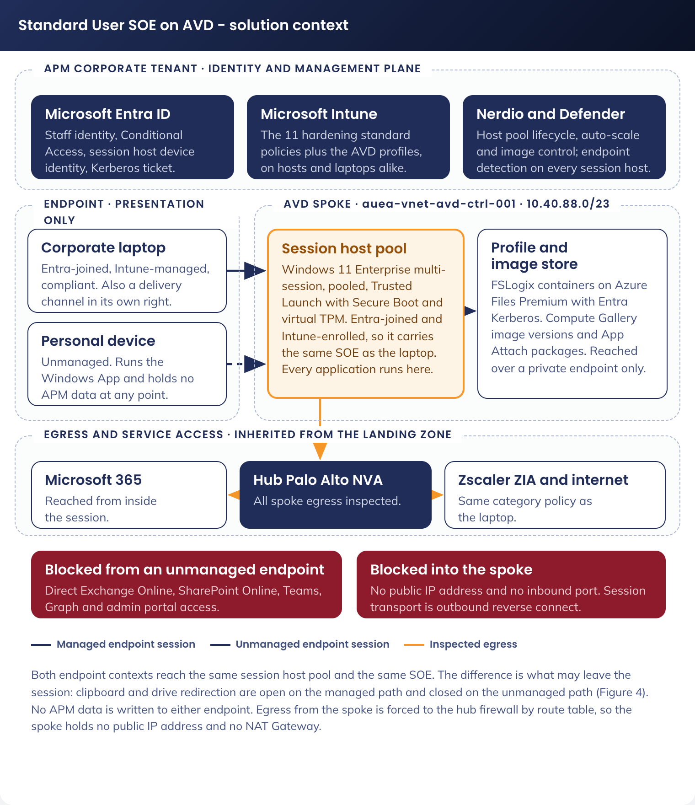
Figure 1. Standard User SOE on AVD - solution context
Figure 1 places the two endpoint contexts, the session host tier inside the AVD spoke, the management and identity plane in the APM corporate tenant, the profile and image storage reached over private endpoints, and the egress path through the hub firewall to Zscaler and the internet. The block from an unmanaged endpoint to Microsoft 365 is shown as a denied path, because it is a control this design depends on rather than an absence.
External system or service | Interaction with this solution
Microsoft Entra ID | Identity for the endpoint sign-in and the session sign-in, Conditional Access evaluation, session host device identity, and the Kerberos ticket that authenticates the profile container mount
Microsoft Intune | Configuration, compliance and application delivery to session hosts and to corporate endpoints. The same policy objects govern both
Azure Virtual Desktop control plane | Session brokering, the reverse connect gateway, host pool and application group objects, and agent registration
Nerdio Manager for Enterprise | Host pool lifecycle, auto-scale, image build and versioning, drain-mode reimaging, and the operational console for Digital Operations
Azure Files Premium | FSLogix profile containers, one share per region, reached over a private endpoint in the AVD spoke
Azure Compute Gallery | Golden image definition, versioning and regional replication. The previous version is the rollback artefact
Microsoft 365 services | Exchange Online, SharePoint Online, OneDrive, Teams and Graph, reached from inside the session
Microsoft Defender for Endpoint | Endpoint detection and response, and vulnerability telemetry from every session host, into the existing tenancy
Zscaler Internet Access | Web filtering, threat protection and logging for browsing from the session, through the Client Connector on the session host
Palo Alto next-generation firewalls (hub) | Inspection and policy enforcement for all traffic leaving the AVD spoke, inherited from the landing zone [CORPUS: Part1-Core-Architecture-As-Built.md]
Microsoft Sentinel | The correlation, retention and evidence layer for host pool, session host, Nerdio, storage, identity and firewall telemetry, in the security subscription

4.2 Solution/Product Component Inventory
Component | Identifier | Licensing | Status
AVD host pool (pooled, breadth-first) | `auea-avdhp-avd-ctrl-staff-001` (5.1.5) | Native AVD. User access right carried by the existing Microsoft 365 E5 entitlement (A-01) | New
AVD workspace | `auea-avdws-avd-ctrl-staff-001` (5.1.5) | Native AVD | New
Desktop application group, managed endpoints | `auea-avdag-avd-ctrl-staff-managed-001` (5.1.5) | Native AVD | New
Desktop application group, unmanaged endpoints | `auea-avdag-avd-ctrl-staff-unmanaged-001` (5.1.5) | Native AVD | New
Validation host pool | `auea-avdhp-avd-ctrl-staffval-001` (5.1.5) | Native AVD | New
Session host virtual machines | Prefix `aevmacstd` plus a Nerdio numeric suffix (5.1.5) | Compute consumption. The operating system use right comes from the user licence (A-01), not from the virtual machine | New
Session host operating system | Windows 11 Enterprise multi-session 24H2 | Windows 11 Enterprise E5 user subscription licence within Microsoft 365 E5 (A-01) | New standard, approval requested (5.1)
Nerdio Manager for Enterprise | Existing instance | Per named user | Reused
Azure Files Premium, FSLogix share | `aestacfslogix001` (5.1.5) | Provisioned capacity | New
Azure Compute Gallery and image definition | `aegalacstaff001`, `auea-img-avd-ctrl-w11ms-001` (5.1.5) | Native Azure | New
Golden image | Versioned image definition, one version per monthly cycle | Image of operating system and applications | New
FSLogix agent, AVD agent and boot loader | Within the golden image | Included with Windows Enterprise / native AVD | New, within image
Microsoft 365 Apps for Enterprise | Within the golden image, shared computer activation enabled | Microsoft 365 E5 (A-01) | Reused from laptop SOE
Microsoft Teams with AVD media optimisation | Within the golden image | Microsoft 365 E5 (A-01) | New, within image
Microsoft Edge | Within the golden image | Included with Windows | Reused from laptop SOE
Microsoft Defender for Endpoint | On every session host | Per existing entitlement | Reused from laptop SOE
Zscaler Client Connector | Within the golden image, machine tunnel mode | Existing Zscaler tenancy | Reused from laptop SOE
MSIX App Attach catalogue | `aestacappattach001` (5.1.5) | Nerdio-orchestrated | New
Intune configuration profiles | 11 hardening policies reused, plus the three AVD profiles named in 5.1.5 | Per existing entitlement | Reused and new
Multi-session compliance policy | `AVD-W11-COM-Session Host-P-1.0` (5.1.5) | Per existing entitlement | New
App Control for Business policy | Existing workstation Audit and Enforced pair, base policy v2026.03.27.0216, 18 trusted signers | Native Windows | Reused unchanged (DR-010)
Conditional Access policies | `CA-202` and `CA-210`, plus the amendments named in 7 | Entra ID P2, existing entitlement | New and amended
Entra ID groups | Seven groups, named in 5.1.5 | Existing entitlement | New
Windows App | Intune-deployed to corporate endpoints; user-installed on personal devices | Free | New deployment of an existing client
Route table, network security groups, private endpoints | Named in 5.1.5 | Native Azure | New within an existing spoke
Log Analytics workspaces and Microsoft Sentinel | `auea-law-mgmt-operation-001`, `auea-law-sec-001` [CORPUS: Part1-Core-Architecture-As-Built.md] | Existing platform | Reused

Two components a reader may expect are absent by design. No Azure Firewall or NAT Gateway is deployed in the AVD spoke, because the landing zone already forces spoke egress through the hub Palo Alto firewalls and prohibits public IP addresses outside the connectivity subscription (DR-006). No Azure Bastion or jump host is deployed for session host administration, because a pooled session host is a disposable object managed through Nerdio and Intune, and administrative access to the guest operating system is not part of the operating model.

4.3 Solution Interface Diagram
Figure 2 traces a single sign-in from an endpoint to a working session, with each interface labelled by its catalogue identifier in 4.4.
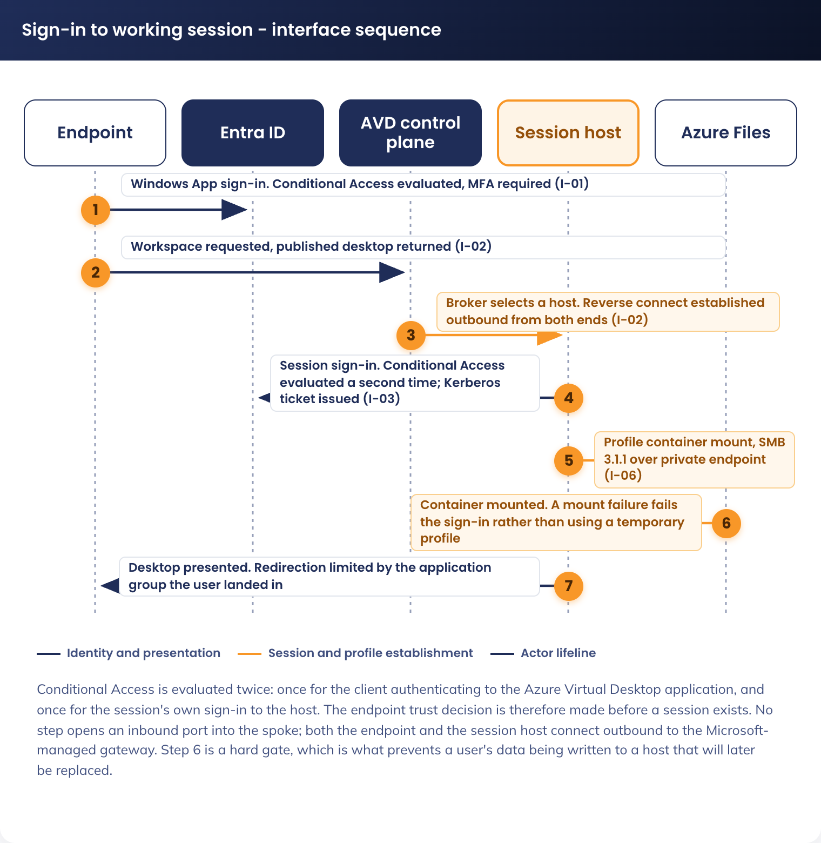
Figure 2. Sign-in to working session - interface sequence
The sequence carries three facts a reviewer should note. Conditional Access is evaluated twice, once for the client authenticating to the Azure Virtual Desktop application and once for the session's own sign-in to the session host, so the endpoint trust decision is made before any session exists. The profile container mount is a hard gate: if the container cannot mount, sign-in fails rather than proceeding with a temporary profile, which is what prevents a user's data being written to a host it will not persist on. And no step in the sequence traverses an inbound port into the spoke; the session host establishes the transport outbound to the AVD gateway.

4.4 Solution/Product Interface catalogue
ID | Interface | Protocol and port | Authentication | Purpose and path
I-01 | Endpoint to Entra ID | HTTPS, TCP 443 | OAuth 2.0 and OpenID Connect, plus multi-factor authentication | Windows App sign-in and Conditional Access evaluation. Public internet, Microsoft-managed
I-02 | Endpoint to AVD gateway | HTTPS, TCP 443 outbound; UDP 3478 for RDP Shortpath where the network permits it | AVD reverse connect transport, brokered | Session establishment. No inbound port is opened at either end; both the endpoint and the session host connect outbound
I-03 | Session host to Entra ID | HTTPS, TCP 443 | Device join, primary refresh token, and the Kerberos ticket for I-06 | Host device identity and the session's user sign-in. Egress through the hub firewall
I-04 | Session host to Intune | HTTPS, TCP 443 | MDM enrolment and policy channel | Configuration profile, compliance and application delivery. Egress through the hub firewall
I-05 | Session host to AVD control plane | HTTPS, TCP 443 | AVD agent registration token, then agent identity | Agent heartbeat, session orchestration and host pool registration. Egress through the hub firewall
I-06 | Session host to Azure Files Premium | SMB 3.1.1, TCP 445, encryption in transit required | Kerberos ticket issued by Microsoft Entra ID | FSLogix profile container mount. Private endpoint inside the AVD spoke. TCP 445 never leaves the virtual network
I-07 | Session host to Microsoft 365 | HTTPS, TCP 443 | Modern authentication as the signed-in user | Exchange Online, SharePoint Online, OneDrive, Teams and Graph from inside the session. Egress through the hub firewall
I-08 | Session host to Defender for Endpoint | HTTPS, TCP 443 | Onboarded device identity | Endpoint detection and response telemetry. Egress through the hub firewall
I-09 | Session host to Zscaler Internet Access | HTTPS, TCP 443, Client Connector tunnel | Machine tunnel, device-bound | Web filtering and logging for browsing from the session. Egress through the hub firewall, then to the Zscaler edge
I-10 | Session host to Azure Compute Gallery and App Attach storage | HTTPS, TCP 443; SMB, TCP 445 for VHDX mount | Managed identity | Image provisioning and on-demand application package mount. Private endpoint inside the AVD spoke
I-11 | Nerdio to Azure Resource Manager and the AVD control plane | HTTPS, TCP 443 | Managed identity and service principal | Host pool lifecycle, auto-scale actions, image build and reimaging. Management plane, not in the session path
I-12 | Session host to Windows Update and Delivery Optimization | HTTPS, TCP 443 | None (service endpoints) | Image build only. Session hosts in production are replaced rather than patched (DR-015), so this interface is not used in steady state
I-13 | Platform telemetry to Log Analytics and Microsoft Sentinel | HTTPS, TCP 443 | Managed identity, diagnostic settings and data collection rules | Host pool, session host, storage, network and Nerdio telemetry into the workspaces named in 9.2
I-14 | Media redirection, endpoint to Teams service | HTTPS, TCP 443 and UDP media | As the signed-in user on the endpoint | Teams audio, video and screen share are handled by the endpoint, not the session host. This is the only interface where an application's traffic does not traverse the session host

5. Technology Architecture
The architecture has three planes. The endpoint plane is the user's point of access and holds no APM data. The compute plane is the pooled session host fleet in the AVD spoke, orchestrated by Nerdio. The platform plane is inherited: identity, management, profile and image storage, egress inspection, and the logging and monitoring estate.

5.1 Technology Component Standards
Domain | Component standard | Status
Session host operating system | Windows 11 Enterprise multi-session 24H2 | New, approval requested
Endpoint operating system (corporate channel) | Windows 11 Enterprise 24H2 | Approved, laptop SOE
Endpoint client | Microsoft Windows App, current general availability release | Approved
Identity | Microsoft Entra ID P2 | Approved
Device management | Microsoft Intune | Approved
Virtual desktop service | Azure Virtual Desktop, pooled host pool, breadth-first load balancing | New, approval requested
Virtual desktop orchestration | Nerdio Manager for Enterprise, current general availability release | Approved
Session host virtual machine size | Standard_D8s_v5, 8 vCPU and 32 GiB memory, as the baseline, tuned during the pilot against observed concurrency | New, baseline recommendation
Session host security profile | Trusted Launch, with Secure Boot and virtual TPM enabled | Approved
Session host disk | Premium SSD managed disk, platform-managed key encryption | Approved
Availability | Availability zone spread across the zones available in Australia East | Approved
Profile storage | Azure Files Premium, provisioned tier, Microsoft Entra Kerberos authentication, private endpoint only | New, approval requested
Image store | Azure Compute Gallery with regional replication | New, approval requested
Endpoint security | Microsoft Defender for Endpoint | Approved
Web filtering | Zscaler Internet Access through the existing tenancy | Approved
Egress inspection | Hub Palo Alto VM-Series next-generation firewalls, inherited [CORPUS: Part1-Core-Architecture-As-Built.md] | Approved, inherited
Network egress from the spoke | Forced tunnel by user-defined route to the hub firewall. No NAT Gateway, no public IP address in the spoke | Approved, inherited (DR-006)
Name resolution | Azure-provided DNS in the spoke, with central private DNS zones linked from the connectivity subscription [CORPUS: Part1-Core-Architecture-As-Built.md] | Approved, inherited
Logging and monitoring | Azure Monitor with Log Analytics, and Microsoft Sentinel in the security subscription | Approved, inherited

5.1.5 Naming Convention
Three naming standards govern this solution, and they govern different planes. The APM Intune Naming Schema V1.0 names Intune objects and Entra ID security groups. The Conditional Access plane has its own established tenant convention and is not governed by the Intune schema. The APM Azure ESLZ Naming Standard names Azure resources. Every object this design creates is named to the applicable one, and where a standard holds no value for something this design needs, the required value is marked as proposed and raised as an addendum item for APM ITS management approval rather than invented silently (DR-017).
Intune objects. The schema's convention is Scope-Platform-Type-Function-Ring-Version. This design proposes one new Scope value, AVD, on the same basis as the existing CDG value: a distinct managed device population needing its own assignment scope. Platform is W11, because multi-session is an edition of Windows 11 rather than a separate platform.
Object | Name | Schema derivation
FSLogix profile container profile | AVD-W11-CFG-FSLogix Profile-P-1.0 | AVD scope, Windows 11, general configuration, production, version 1.0
Session time limits profile | AVD-W11-CFG-Session Time Limits-P-1.0 | General configuration (DR-014)
Multi-session host behaviour profile | AVD-W11-CFG-Multi-Session Host-P-1.0 | General configuration: shared computer activation and the multi-session settings the laptop channel does not carry
Compliance policy | AVD-W11-COM-Session Host-P-1.0 | Business compliance. The multi-session counterpart to Staff-Windows-Compliance-Policy (7, SOE-01)
Win32 applications | AVD-W11-APPC-[Application]-P-1.0 | Application configuration, for the applications that cannot be packaged as MSIX (5.4.5)
Inherited hardening policies | APM-W11-SEC-Baseline-P-1.2, APM-WIN-SEC-ASR-P-1.0, APM-W11-SEC-Edge Baseline-P-1.2, APM-W11-SEC-Edge Dev Baseline-P-2.0, APM-Edge-Hardened-Baseline-V1.0-Accessibility, APM-Edge-Hardened-Baseline-V1.0-LastPass, APM-WIN-SEC-USB Baseline-P-1.0, APM-W11-SEC-Bitlocker-P-1.1, and the App Control Audit and Enforced pair | Existing names, unchanged. Only the assignment scope changes (DR-001), so this design creates no new name
Update ring | None | Session hosts are replaced from a new image version rather than patched in place (DR-015), so this design creates no UPD object. A deliberate absence, not an omission

Entra ID security groups. The schema's convention is sg-[assignment]-[entity]-[scope]-[function], with stc for a static group and dyn for a dynamic one, and dvc or usr for the entity.
Group | Name | Purpose
Session host device group | sg-dyn-dvc-avd-session-hosts | Dynamic, device-based, AVD scope. Matched on the session host name prefix and cloud-only Entra join type. The assignment target for the inherited hardening policies, the AVD profiles and the compliance policy
Pilot host ring | sg-stc-dvc-avd-session-hosts-ring1 | Static, because membership is chosen rather than derived. Policy and image changes land here first (9.1)
AVD entitlement | sg-stc-usr-avd-standard-user | Every staff member entitled to AVD. Drives workspace publication and profile share entitlement
Managed-endpoint desktop | sg-stc-usr-avd-desktop-managed | Assigned to the managed desktop application group, which has clipboard and drive redirection enabled (7)
Unmanaged-endpoint desktop | sg-stc-usr-avd-desktop-unmanaged | Assigned to the unmanaged desktop application group, which has clipboard and drive redirection disabled (7)
AVD operators | sg-stc-usr-avd-operators | Nerdio operators and host pool administrators. Eligible only through Privileged Identity Management, never standing
Image build identities | sg-stc-usr-avd-image-builders | The identities permitted to write a new image version to the Compute Gallery

Conditional Access policies. The tenant convention is CA-nnn - audience - apps - condition - action, with the number series allocated by audience: CA-1xx for all users and guests, CA-2xx for organisation users, CA-4xx for administrators and CA-5xx for guests. Both policies this design creates target organisation users, so both take numbers in the CA-2xx series. The Intune Naming Schema does not govern this plane, and naming a Conditional Access policy to the Intune convention would present it as an object created outside the tenant's own process.
Policy | Number and name | Note
Require multi-factor authentication for AVD | CA-202 - Org Users - Azure Virtual Desktop - Allow - Require MFA | CA-202 is unused in the 7 August 2026 export. CA-200, CA-201 and CA-203 onwards are in use
Block non-AVD access from unmanaged devices | CA-210 - Org Users - Microsoft 365 exc. AVD - Unmanaged Devices - Block | CA-210 is unused in the 7 August 2026 export

Four numbers in the CA-2xx series are already carried by two policies each in the tenant export, so both numbers above are confirmed unused immediately before the policy is created rather than assumed from the export.
Azure resources. The ESLZ standard's general form is [region]-[abbreviation]-[environment]-[apm security domain]-[descriptor]-[instance], with a shortform concatenated variant where Azure constrains the name, as it does for storage accounts, virtual machines and Compute Galleries [CORPUS: Part3-IPAM-Policy-Standards.md]. The environment token for this workload is avd and the security domain is ctrl, both fixed by the existing virtual network name auea-vnet-avd-ctrl-001.
Resource | Name | Note
Virtual network | auea-vnet-avd-ctrl-001 | Exists [CORPUS: Part3-IPAM-Policy-Standards.md]
Subnets | auea-snet-avd-ctrl-[descriptor]-001 | Four, 5.3.3
Route table | auea-rt-avd-ctrl-001 | Matches the as-built pattern for every other spoke, for example auea-rt-prod-ctrl-001 [CORPUS: Part1-Core-Architecture-As-Built.md]
Network security groups | auea-nsg-avd-ctrl-[descriptor]-001 | One per subnet, 5.3.7
Private endpoints | auea-pep-avd-ctrl-[descriptor]-001 | Three, 5.3.6
Resource groups | auea-rg-avd-ctrl-[compute, storage, image, net]-001 | Four
Host pool, workspace and application groups | auea-avdhp-avd-ctrl-staff-001, auea-avdws-avd-ctrl-staff-001, auea-avdag-avd-ctrl-staff-managed-001, auea-avdag-avd-ctrl-staff-unmanaged-001 | The abbreviations avdhp, avdws and avdag are not in the ESLZ abbreviation registry. Proposed as additions (DR-017)
Storage accounts | aestacfslogix001, aestacappattach001 | Shortform concatenated, as the standard requires for storage accounts: region ae, type st, environment shortform for avd, domain c for controlled, then descriptor and instance. The environment shortform a is not in the standard and is proposed as an addition (DR-017)
Compute Gallery and image definition | aegalacstaff001, auea-img-avd-ctrl-w11ms-001 | A Compute Gallery name cannot contain a hyphen, so it takes the shortform concatenated variant. The abbreviations gal and img are proposed additions (DR-017)
Session host virtual machines | Prefix aevmacstd, with Nerdio appending a numeric suffix | Follows the ESLZ server-host virtual machine format [region:sf][vm][env:sf][domain:sf][descriptor][instance] [CORPUS: Part3-IPAM-Policy-Standards.md]. The prefix is 9 characters, so the full name stays inside the 15-character Windows hostname limit at any fleet size this design supports. The session host device group matches on this prefix

5.2 Integration standards and patterns
N/A - this design introduces no integration pattern. There is no new application programming interface, no extract-transform-load process, no message broker, no middleware and no bespoke integration. Every interaction in 4.4 is either a Microsoft cloud service consumed with modern authentication, or a management-plane call made by Nerdio with a managed identity. The interfaces themselves are catalogued in 4.4 and their network paths in 5.3.

5.3 Network & Infrastructure Standards & Patterns
This design allocates subnets and controls inside a virtual network that the landing zone has already created and peered. It does not create a spoke, a CIDR allocation, a firewall or an egress path. Facts about the existing estate carry a corpus citation; identifiers this design invents are marked as proposed and require the decision-register row that names them.

5.3.1 Naming convention
Network object names are specified with every other object in this solution in 5.1.5, which is the single home for the naming convention in this design. The network objects named there are the four subnets, the route table, the four network security group assignments, the three private endpoints and the network resource group.

5.3.2 Address plan and reserved ranges
Australia East uses the supernet `10.40.0.0/16` and Australia Southeast `10.50.0.0/16`, allocated under landing zone decision DD11 [CORPUS: Part3-IPAM-Policy-Standards.md].
Allocation | CIDR | Note
Australia East supernet | `10.40.0.0/16` | Regional supernet [CORPUS: Part3-IPAM-Policy-Standards.md]
`auea-vnet-avd-ctrl-001` | `10.40.88.0/23` | The AVD spoke. 512 addresses, 507 usable after the five Azure reserves per subnet. This design allocates within it and requests no new CIDR
Reserved for contiguous growth | `10.40.90.0/23`, `10.40.92.0/23`, `10.40.94.0/23` | Held for this virtual network by the address plan. A second host pool, a second profile share or a personal-desktop pool is added from here without re-addressing [CORPUS: Part3-IPAM-Policy-Standards.md]
Hub, Australia East | `10.40.0.0/23` | `auea-vnet-connectivity-001`, holds the Palo Alto firewall interfaces and the internal load balancer this design routes to [CORPUS: Part1-Core-Architecture-As-Built.md]
Australia Southeast AVD spoke | `10.50.88.0/23` | `ause-vnet-avd-ctrl-001`, already allocated. The second region is a deployment of this pattern, not a redesign (DR-009) [CORPUS: Part3-IPAM-Policy-Standards.md]

5.3.3 Subnet allocation
Four subnets are allocated from `10.40.88.0/23`. The session host subnet is sized for the fleet plus reimaging headroom: a drain-mode reimage runs replacement hosts alongside the hosts being retired, so the subnet must hold more addresses than the steady-state host count.
Subnet | CIDR | Usable | NSG | Purpose
`auea-snet-avd-ctrl-hosts-001` | `10.40.88.0/24` | 251 | `auea-nsg-avd-ctrl-hosts-001` | Session host network interfaces. Sized for the steady-state fleet plus concurrent reimaging headroom
`auea-snet-avd-ctrl-pe-001` | `10.40.89.0/27` | 27 | `auea-nsg-avd-ctrl-pe-001` | Private endpoints: FSLogix profile storage, App Attach storage, Compute Gallery
`auea-snet-avd-ctrl-mgmt-001` | `10.40.89.32/27` | 27 | `auea-nsg-avd-ctrl-mgmt-001` | Nerdio-provisioned scratch objects and break-glass image work. Routine image build runs in the test environment (Appendix B). No production session host uses this subnet
`auea-snet-avd-ctrl-hosts-002` | `10.40.89.64/26` | 59 | `auea-nsg-avd-ctrl-hosts-001` | Second host pool or a personal-desktop pool, allocated now so a later pool does not force a re-plan
Unallocated | `10.40.89.128/25` | - | - | Held inside the virtual network for future subnets

The subnet, network security group and route table names follow 5.1.5. They are confirmed against the live estate before build, because the landing zone address plan records the virtual network allocation but not its subnet layout.

5.3.4 Routing
Egress follows the landing zone forced-tunnel pattern without variation: every subnet in every spoke carries a route table with a default route to the hub Palo Alto next-generation firewall, so north-south and east-west flows are both inspected and no spoke can bypass inspection by peering [CORPUS: Part1-Core-Architecture-As-Built.md].
Route name | Prefix | Next hop type | Next hop address
`Routes-to-Firewall` | `0.0.0.0/0` | Virtual appliance | The internal load balancer frontend in the hub private subnet `auea-snet-private-001`, fronting the east-west firewall backend pool. The as-built does not state the frontend IP address, and the deployed route tables carried a placeholder of `1.1.1.1` pending firewall deployment [CORPUS: Part1-Core-Architecture-As-Built.md]. `[UNKNOWN]` - the live value must be read from a deployed spoke route table and confirmed by Network Management before the first session host is provisioned

Route table setting | Value
Name | `auea-rt-avd-ctrl-001` (5.1.5)
Propagate gateway routes | Disabled, matching every deployed route table in the estate [CORPUS: Part1-Core-Architecture-As-Built.md]
Subnet associations | All four subnets in 5.3.3
Route priority | User-defined route over BGP over system route, per the landing zone routing model [CORPUS: Part1-Core-Architecture-As-Built.md]

Two consequences of this routing model are load-bearing for the rest of the design. First, session host traffic to Microsoft 365, Entra ID, Intune, the AVD control plane and Defender for Endpoint all leave through the hub firewall, so the firewall policy in 5.3.8 has to permit them explicitly. Second, the AVD reverse connect transport is outbound from the session host, so it is subject to the same egress policy: if the firewall does not permit the AVD control plane and gateway FQDNs, no session host can register and no session can be brokered. Verifying that permission is a prerequisite for the first host, not a pilot finding.

5.3.5 DNS
The landing zone resolves names cloud-natively. Private DNS zones are created and managed centrally in the connectivity subscription in resource group `auea-rg-connectivity-dns-001`, spoke virtual networks are linked to them, and virtual networks use Azure-provided DNS with no custom DNS server configured [CORPUS: Part1-Core-Architecture-As-Built.md].
Requirement | Design
Session host resolver | Azure-provided DNS. No custom DNS server is set on the AVD spoke, matching every other spoke in the estate
Private endpoint resolution | Three private DNS zones are required for the private endpoints in 5.3.6: `privatelink.file.core.windows.net` and `privatelink.blob.core.windows.net` for the storage accounts, and the Compute Gallery private link zone. Each must exist centrally in the connectivity subscription and be linked to `auea-vnet-avd-ctrl-001`
Zone creation constraint | Private DNS zone creation is policy-controlled: policy APM001 audits or denies Private Link private DNS zones at APM scope, and APM007.1 and APM007.2 deny private DNS at the Platform and Region scopes [CORPUS: Part1-Core-Architecture-As-Built.md]. Any zone this design needs that does not already exist must be created by the platform team in the connectivity subscription, or a scoped policy exemption obtained. This is a dependency on Network Management, not a task inside this build
Public name resolution | Microsoft cloud service FQDNs resolve publicly through Azure-provided DNS. The firewall, not DNS, is the control point for what a session host may reach (5.3.8)
Active Directory dependency | None. The session host is Entra-joined only (DR-003) and does not resolve or contact a domain controller. The regional AD DS virtual machines in the identity subscription are not in this solution's path

5.3.6 Private endpoints
Every storage service this solution consumes is reached over a private endpoint in `auea-snet-avd-ctrl-pe-001`, with public network access disabled on the resource. Names follow 5.1.5.
Private endpoint | Sub-resource | Target | Consumed by
`auea-pep-avd-ctrl-fslogix-001` | `file` | Azure Files Premium profile share | Session host FSLogix agent (I-06). SMB on TCP 445 never leaves the virtual network
`auea-pep-avd-ctrl-appattach-001` | `file` | App Attach package share | Session host MSIX VHDX mount (I-10)
`auea-pep-avd-ctrl-gallery-001` | `galleries` | Azure Compute Gallery | Session host provisioning from an image version (I-10)

5.3.7 Network security group baseline
Each subnet carries its own network security group. The baseline is default-deny inbound with only the platform-required flows permitted, and outbound constrained to the destinations the session host legitimately needs. Outbound rules are written as a second line of defence: the route table already sends every packet to the hub firewall, which is the primary policy point.
`auea-nsg-avd-ctrl-hosts-001`, session host subnet
Pri | Name | Source | Destination | Port | Action | Direction
100 | `AllowVnetInbound` | `VirtualNetwork` | `VirtualNetwork` | Any | Allow | Inbound
4096 | `DenyAllInbound` | Any | Any | Any | Deny | Inbound
100 | `AllowAzureCloudOut` | `10.40.88.0/24` | `AzureCloud.australiaeast` | 443 | Allow | Outbound
110 | `AllowWindowsVirtualDesktopOut` | `10.40.88.0/24` | `WindowsVirtualDesktop` | 443 | Allow | Outbound
120 | `AllowAzureFilesOut` | `10.40.88.0/24` | `10.40.89.0/27` | 445 | Allow | Outbound
130 | `AllowEntraKerberosOut` | `10.40.88.0/24` | `AzureActiveDirectory` | 443 | Allow | Outbound
140 | `AllowShortpathOut` | `10.40.88.0/24` | `Internet` | 3478 UDP | Allow | Outbound
150 | `AllowInspectedEgressOut` | `10.40.88.0/24` | `Internet` | 443 | Allow | Outbound
4096 | `DenyAllOutbound` | Any | Any | Any | Deny | Outbound

Rule 150 does not weaken the position: the route table sends that traffic to the hub firewall regardless of the network security group's evaluation, and the firewall policy in 5.3.8 is what decides whether it proceeds. The network security group cannot express FQDN policy, which is why it permits the port and the firewall names the destination.
`auea-nsg-avd-ctrl-pe-001`, private endpoint subnet. Inbound: allow `445` and `443` from `10.40.88.0/24` and `10.40.89.64/26` only; deny all other inbound. Outbound: deny all. A private endpoint originates no traffic.
`auea-nsg-avd-ctrl-mgmt-001`, management subnet. Inbound: deny all. Outbound: `443` to `AzureCloud.australiaeast` and `Internet`, plus `445` to the private endpoint subnet. This is the only subnet in the production spoke where broad package download is permitted, and it holds no production session host. It exists for Nerdio scratch objects and for a break-glass image build; routine image build runs in the equivalent subnet in the test environment (Appendix B), so the production spoke is not where a new image is assembled.

5.3.8 Named egress destinations
The hub firewall policy must permit the following from the AVD spoke. Each is required for a specific function, and the design does not work without it. Palo Alto App-ID and URL categories are used in preference to IP address lists, because every destination below is a Microsoft or vendor service with a changing address space. The east-west firewalls carry Advanced URL Filtering and Advanced DNS Security licences, so category and FQDN policy is available rather than address-based policy alone [CORPUS: Part1-Core-Architecture-As-Built.md].
Destination | Port | Required for
Azure Virtual Desktop control plane and gateway FQDNs, and the Microsoft Windows Virtual Desktop service tag | 443, and 3478 UDP for Shortpath | Agent registration, session brokering and the reverse connect transport. Without this, no session host can join a host pool
`login.microsoftonline.com`, `login.microsoft.com`, `device.login.microsoftonline.com`, `enterpriseregistration.windows.net` | 443 | Entra join, device authentication, user sign-in and the Kerberos ticket for the profile mount
Microsoft Intune service endpoints (`manage.microsoft.com` and the regional equivalents) | 443 | MDM enrolment, configuration profile and compliance evaluation, and Win32 application delivery
Microsoft 365 endpoints for Exchange Online, SharePoint Online, OneDrive, Teams and Graph | 443 | Every productivity workload inside the session
Microsoft Defender for Endpoint service endpoints | 443 | Endpoint detection and response telemetry and vulnerability reporting
Zscaler Client Connector registration and the ZIA edge | 443 | Web filtering and logging for browsing from the session
Windows Update, Delivery Optimization and the Microsoft 365 Apps content delivery network | 443 | Image build only, from `auea-snet-avd-ctrl-mgmt-001`. Production session hosts do not patch in place (DR-015)
Azure Storage and Azure Compute Gallery | 443 | Reached over private endpoint from the spoke, so no firewall rule is required for the data path. Listed to record that the public path is deliberately not permitted
Nerdio Manager backend | 443 | Management plane, originating from the Nerdio application rather than from a session host. Not an AVD spoke egress flow

Everything not named above is denied. In particular the session host has no permitted path to the corporate on-premises network, to a domain controller, or to any other spoke: the hub firewall's east-west policy governs spoke-to-spoke traffic, and this design requests no spoke-to-spoke rule.

5.3.9 Connectivity, resilience and capacity
Aspect | Design
Peering | `auea-vnet-avd-ctrl-001` to `auea-vnet-connectivity-001`, bidirectional, already in place [CORPUS: Part1-Core-Architecture-As-Built.md]. This design adds no peering. Spoke-to-spoke traffic is not peered and transits the hub firewall by route
Session host placement | Spread across the availability zones available in Australia East, so the loss of a single zone removes a proportion of capacity rather than the service. Auto-scale replaces lost hosts from the image
Firewall path resilience | Inherited: dual north-south and east-west firewall sets behind Azure load balancers in the hub, with Panorama in an active-passive pair across the two regions [CORPUS: Part1-Core-Architecture-As-Built.md]. A hub firewall failure is a platform incident that affects every spoke, not an AVD-specific single point of failure
Profile storage resilience | Azure Files Premium with zone-redundant storage in Australia East, plus share snapshots as the profile-level recovery point (8.2)
Reverse connect dependency | Session establishment depends on the Microsoft-managed AVD gateway. A control plane incident in the region prevents new sessions being brokered; existing connected sessions are unaffected while the transport holds. This is an accepted residual risk at the service tier in 8.1
Bandwidth per session | Sized on the Microsoft guidance for a productivity workload with Teams media offloaded to the endpoint [EXTERNAL]. The constraining link is the user's own internet connection, not the spoke, because the spoke egress is Azure backbone capacity
Hybrid connectivity | Not provisioned by this design. The hub holds a GatewaySubnet and VPN gateway capability, so a future requirement (for example GAP-01 resolving to an on-premises SMB share) is a hub change and a firewall rule, not a re-addressing exercise [CORPUS: Part1-Core-Architecture-As-Built.md]

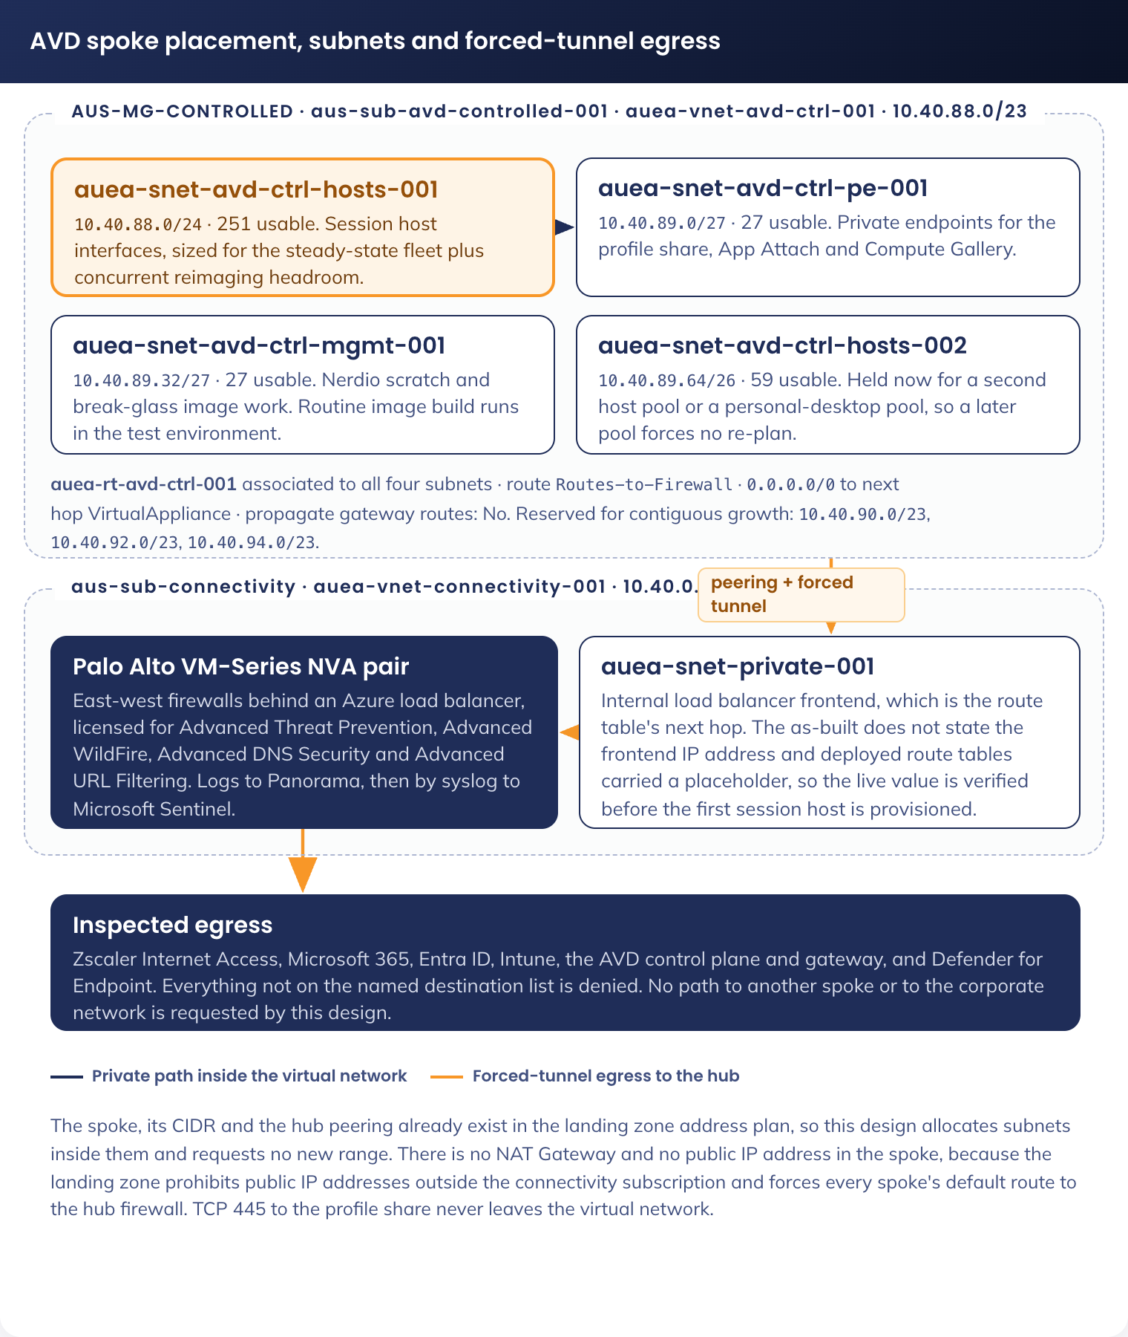
Figure 3. AVD spoke placement, subnets and forced-tunnel egress

5.4 Technology component Deployment Patterns

5.4.1 Golden image build and replication
The image is the unit of change. Application delivery, operating system patching and configuration drift remediation all resolve to a new image version, and the previous version is the rollback.
1. Provision a build virtual machine in the test environment's build subnet (Appendix B) from the Windows 11 Enterprise multi-session 24H2 marketplace image. The production spoke is not used for routine image assembly
2. Install Microsoft 365 Apps for Enterprise with shared computer activation enabled, which is required because many users sign in to the same host
3. Install Microsoft Teams with the AVD media optimisation components, so media is handled by the endpoint (I-14)
4. Install Microsoft Edge, the Visual C++ and .NET runtimes, and the baseline line-of-business applications that must exist before first sign-in (DR-008)
5. Install the FSLogix agent, the AVD agent and boot loader, the Azure Monitor agent, and the Zscaler Client Connector in machine tunnel mode
6. Apply the image-time configuration that cannot be delivered by policy, then remove the build artefacts and local profiles
7. Generalise the image and capture it to the Compute Gallery as a new version of the image definition
8. Replicate the version to Australia East, and to any additional region in scope
9. Reimage the test environment host pool to the new version and run the full test set in Appendix B.6, which is the substantive validation
10. Reimage the production validation host pool to the new version and repeat the connection and profile checks, which is the only place the production firewall policy, production profile share and production Conditional Access set are exercised together
11. Promote to the production host pool through the Nerdio image update workflow with drain-mode reimaging (5.4.3)

5.4.2 Host pool configuration
Setting | Value
Host pool type | Pooled
Load balancing algorithm | Breadth-first, so sessions distribute across available hosts rather than filling one host at a time. Depth-first would concentrate load and make a single host failure affect more users
Maximum session limit per host | 8 on the `Standard_D8s_v5` baseline, tuned during the pilot against observed processor, memory and profile input/output
Validation environment | Two distinct things, both required. The test environment (Appendix B) proves a change before it goes near production, and is where an image is built and a policy, network rule or Conditional Access change is first exercised. The production validation host pool holds one host on the newest image version, drained except during validation, and exists because the test environment cannot exercise the production firewall policy, the production profile share or the production Conditional Access set
Start virtual machine on connect | Enabled, so a user connecting outside scale-out hours starts a host rather than being refused
Session limits | Idle disconnect at 1 hour, disconnected sign-out at 4 hours (DR-014)
Application groups | Two desktop application groups on this host pool, differing only in RDP properties (DR-013, 7)

5.4.3 Host pool lifecycle through Nerdio
Operation | Design
Provisioning | Nerdio provisions session hosts from the current Compute Gallery image version into `auea-snet-avd-ctrl-hosts-001`, joins them to Entra ID, and they enrol into Intune automatically
Auto-scale | Scale out ahead of the working day, hold capacity through it, scale in after it, with a minimum capacity retained overnight for out-of-hours work. At least one available host is held as buffer during business hours so a user never waits for a virtual machine to start. Exact schedule and thresholds are in the companion Technical Configuration Document
Reimaging | Drain mode is set on a host, existing sessions are allowed to end, then the host is replaced from the new image version. No active session is interrupted, which is what requirement 07 asks for
Rollback | Reimage from the previous image version in the Compute Gallery. This is the recovery control for a bad image and is tested as part of the pilot (8.2)
Host replacement on failure | A failed host is drained and replaced. No user data is lost, because user state is in the profile container, not on the host
Scale-in safety | A host is only removed once it holds no session. The 4-hour disconnected sign-out in DR-014 is what makes scale-in possible: without it a disconnected session would hold a host indefinitely

5.4.4 Intune policy delivery to session hosts
Session hosts enrol into Intune at Entra join. A dynamic device group scoped to the session host naming pattern and cloud-only join type is the assignment target for both the inherited hardening standard policies and the AVD-specific profiles. Policy applies on the standard MDM check-in cycle, and compliance state is what Conditional Access consumes.
Because a pooled session host is replaced on every image cycle, policy application is re-evaluated on every new host. A policy that fails to apply therefore shows as a fleet-wide pattern rather than a single stale device, which makes the Intune reporting in 9.2 the primary detection for a broken profile.

5.4.5 Application delivery
Delivery method | What goes here | Why
Baked into the image | Microsoft 365 Apps, Teams, Edge, Defender, FSLogix agent, AVD agents, Zscaler Client Connector, runtimes, and the baseline line-of-business set | Required before first sign-in, needed by every session, or a system component that cannot be layered
MSIX App Attach through Nerdio | The broad line-of-business application set | A package update is a catalogue change, not an image rebuild, so the monthly image cycle is not the constraint on application currency
Intune Win32 | Applications that cannot be packaged as MSIX, and anything needed by a subset of users | Reuses the packaging the laptop channel already has
Not delivered | Anything requiring a local administrator to install, or a device driver for a peripheral attached to the endpoint | A standard user in a session has no elevation path, and endpoint peripherals are handled by redirection, not by drivers on the host

5.4.6 Windows App deployment to endpoints
Corporate Entra-joined endpoints receive the Windows App as a required application from Intune, so no user action is needed. On a personal device the user installs the Windows App from their platform's own store and signs in with their APM identity; the workspace and the desktop icon are then published to them by group membership. No APM software is installed on a personal device beyond the vendor client, and no APM management agent is placed on it.

6. Information & Data Architecture

6.1 Information Model
This design introduces no new data store. User data exists in three places: transiently in the session on the session host, persistently in the user's FSLogix profile container, and in the Microsoft 365 services the user works with from inside the session. It exists in no fourth place, and specifically not on the endpoint.
Data | Location | Persistence | Protection
Session state: memory, temporary files, the session desktop | Session host virtual machine | Destroyed at sign-out; lost on host replacement | Platform disk encryption; no user data survives the host
User profile: registry hive, application data, desktop, documents, Outlook cache, Teams cache, OneDrive cache, Edge profile | FSLogix container on Azure Files Premium, one per user | Persists across sessions and across host replacement | Encryption at rest with platform-managed keys; SMB 3.1.1 with encryption in transit; Entra Kerberos authentication; private endpoint only. Edge password manager is disabled by the inherited Edge baseline, so no credential is stored in the profile
Mail | Exchange Online, with the local cache inside the profile container | Existing Exchange Online retention | Existing Microsoft 365 controls, unchanged by the channel
Documents | SharePoint Online and OneDrive, with the sync cache inside the profile container | Existing SharePoint and OneDrive retention | Existing Microsoft 365 controls, unchanged by the channel
Data carried out of the session by a user | Managed endpoint: clipboard and redirected drive. Unmanaged endpoint: neither | Not applicable | This is the control in DR-013. On an unmanaged endpoint there is no path for a file to leave the session
Platform and security telemetry | Log Analytics workspaces and Microsoft Sentinel | 90 days operational, 30 days security, with export to 180-day lifecycle storage [CORPUS: Part1-Core-Architecture-As-Built.md] | Named in 9.2. The security workspace shortfall is R-07

The profile container is the only object in this design that holds user data over time, which makes three of its properties load-bearing. It mounts as a hard gate, so a sign-in that cannot mount the container fails rather than creating a temporary local profile that would strand data on a host. It is per user and per region, so a user's data does not follow them to another jurisdiction. And it is reached only over a private endpoint, so the SMB path that carries it never traverses the internet or the hub firewall.

6.2 Information Classification
Classification follows the data, not the platform. The AVD channel handles the same APM information as the laptop channel: participant personally identifiable information, employment services records, internal correspondence and operational data. Moving a user from laptop to AVD changes neither the classification of what they handle nor the obligations attached to it.
Control | Position on AVD
Encryption in transit | TLS 1.2 as the minimum for every session, management and Microsoft 365 flow, with TLS 1.3 negotiated where both ends support it. SMB 3.1.1 to the profile share with encryption in transit required at the storage account, so the setting cannot be downgraded per connection
Encryption at rest | Azure platform-managed keys on session host managed disks, on Azure Files Premium holding profile containers, and on the Compute Gallery and App Attach storage. Customer-managed keys are available if a classification escalation requires them and are not enabled in this version
Data residency | All session compute, profile data, image storage and application packages for Australian staff reside in Australia East. Australian data leaves the country only as part of Microsoft 365 service traffic APM has already accepted under its existing tenancy arrangements. When a second region is added, the same single-region rule applies per user: session compute and profile data sit in the region the user signs in to (DR-009)
Data egress from the session | Constrained at the host pool by DR-013, and inspected on the network path by Zscaler and the hub firewall. From an unmanaged endpoint there is no clipboard or file path out of the session
Data on the endpoint | None. The endpoint holds the Windows App and a cached sign-in token. No document, mailbox item or profile fragment is written to it
Classification of the platform itself | The AVD subscription sits under the landing zone's Controlled management group, which is the archetype for workloads requiring RFFR compliance [CORPUS: Part1-Core-Architecture-As-Built.md]. Placement therefore asserts the compliance obligation rather than leaving it to be argued

6.3 Analytics and reporting Patterns
N/A - this design introduces no analytics or business intelligence pattern. It creates no reporting data store, no semantic model and no dashboard for business consumption. Operational and security telemetry, its destinations, its retention and the alerting built on it are specified in 9.2, and the workbooks used there are the Microsoft-supplied AVD Insights set rather than an APM-authored reporting layer.

7. Cyber & Security Architecture
The security architecture inherits the laptop SOE baseline and extends it with the controls a multi-session, bring-your-own-device-capable virtual desktop requires. Four positions are argued openly here rather than left to be found in review: access from unmanaged devices, the Conditional Access enforcement changes this design depends on, the inherited application control gap, and the security log retention shortfall.
RFFR and ASD position. APM operates under the Workforce Australia and Inclusive Employment Australia Service Deeds, both requiring compliance with the Right Fit For Risk framework administered by DEWR, which is based on ISO/IEC 27001 and the ASD Information Security Manual. RFFR compliance is managed under APM's existing ISMS. The AVD channel's position rests on three facts. The session host is treated as an endpoint for control purposes, not as server infrastructure, so it inherits the endpoint hardening standard rather than a server baseline. Every control the laptop SOE evidences for RFFR is either applied identically on the session host or replaced by a named compensating control in the SOE alignment tables below. And the subscription's placement under the Controlled management group puts the workload inside the landing zone's RFFR-regulated archetype by construction.
The hardening standard the fleet inherits is the APM Windows SOE Hardening Standard V3.0: 748 controls across 11 Intune policies, benchmarked against ASD Windows hardening guidance, the Microsoft Windows 11 v24H2 baseline and the Microsoft Edge security baseline v139, of which 568 meet or exceed the benchmark, 171 are additional hardening beyond it, and 9 are recorded as partial with a reason. This design changes none of those figures for the laptop channel and inherits all of them for the AVD channel.
Identity and access control. Every user of this solution is an existing APM staff identity in the corporate tenant. No new identity type is introduced, no local account is created on a session host for a user, and no shared account exists. The session host itself holds a device identity in Entra ID, which is what the compliance policy and the device filters below evaluate.
Seven Entra ID security groups carry the model, named in 5.1.5: one dynamic device group holding the session hosts, one static pilot ring of hosts, one entitlement group, two desktop-assignment groups that draw the managed and unmanaged boundary, one operators group and one image-builders group.
Only the session host device group is dynamic. Every user group is static, because a user's membership of a desktop-assignment group decides which side of the redirection boundary they sit on, and that is a decision APM makes rather than a state a sign-in derives.
Azure control plane permissions use the landing zone's platform roles rather than new custom roles: `APMLZ-NetworkManagement` for the route table, network security groups and private endpoints, `APMLZ-ApplicationOwner` for the AVD and compute resources, and `APMLZ-SecurityOperations` for the security estate [CORPUS: Part1-Core-Architecture-As-Built.md]. Two constraints from those roles shape the build: `APMLZ-ApplicationOwner` cannot create a public IP address or a virtual network, which is consistent with DR-006 and 5.3, and every management group role assignment in the estate is time-bound with all assignments expiring in November 2026 and the renewal process not recorded, which is carried as R-06 [CORPUS: Part1-Core-Architecture-As-Built.md].
Conditional Access. This is the control that makes access from an unmanaged device acceptable, and it is the part of the design most likely to be challenged, for a specific reason: the tenant's existing policy set does not currently enforce the boundary this design assumes. The Conditional Access export of 7 August 2026 holds 116 policies, of which 68 are enforced, 43 are report-only and 5 are off. Three of the policies this design depends on are in report-only, and one enforced policy currently permits what this design must prevent.
Existing policy | State | Consequence for this design, and the change required
CA-101 - All Users and Guests - All Apps - Allow - Require MFA | Report-only | Multi-factor authentication is not currently enforced tenant-wide. This design requires multi-factor authentication on every AVD sign-in, so it cannot rely on CA-101 and instead requires an enforced AVD-specific policy. Change required: none to CA-101 by this design; the AVD policy below carries the requirement explicitly
CA-200 - Org Users - Microsoft 365 - Windows, macOS - Client Apps - Allow - Require Hybrid or Compliance | Report-only | This is the policy that would stop an unmanaged Windows or macOS device reaching Microsoft 365 through a desktop client. While it is report-only, an unmanaged device is not blocked. Change required: move to enforced before AVD is opened to personal devices. Without it, DR-007's premise does not hold
CA-201 - Org Users - All Apps - Browser - BYOD - Allow - No Persistence | Enforced, with no grant control | This policy permits unmanaged browser access to all applications and applies only a session control preventing a persistent browser session. It is the direct opposite of requirement 03. Change required: narrow its application scope so it no longer covers the Microsoft 365 workloads that requirement 03 names, or add a grant control requiring a compliant or Entra-joined device
CA-204 - Org Users - Entra Join - Allow - Require MFA | Report-only | Would require multi-factor authentication at Entra join. Session hosts join non-interactively and are unaffected, but the report-only state means the tenant's join-time posture is weaker than the design assumes elsewhere. Change required: none by this design; noted so no control claim rests on it
CA-404 - Administrators - Office 365_AVD - Allow - Token Protection | Report-only | The only existing policy in the tenant that references AVD. It applies token protection to administrators for Office 365 and AVD. Change required: none by this design. Recorded because it is the one existing AVD control and it is not enforced, so this design claims no protection from it
CA-102 / CA-105 / CA-104 - location, bad IP and sign-in risk blocks | Enforced | These apply to AVD sign-ins as they do to any other, and are inherited without change. The Australian location restriction is the reason a staff member travelling overseas cannot reach an AVD session, which is an operational consequence to communicate rather than a defect

Two new policies are required, both scoped to the AVD entitlement group and both numbered in the CA-2xx organisation-user series per 5.1.5.
New policy | Definition
CA-202 - Org Users - Azure Virtual Desktop - Allow - Require MFA | Target applications: Azure Virtual Desktop and Windows Cloud Login. Any device platform, any device state. Grant: require multi-factor authentication, with a sign-in frequency appropriate to a shared-host environment and persistent browser session disabled. This is what permits an unmanaged endpoint to authenticate to AVD at all, and it is the only permission it receives
CA-210 - Org Users - Microsoft 365 exc. AVD - Unmanaged Devices - Block | Target applications: Microsoft 365, excluding Azure Virtual Desktop and Windows Cloud Login. Condition: device is not compliant and not Entra-joined. Grant: block. This is the enforced statement of requirement 03. It duplicates the intent of CA-200 deliberately, because CA-200 is report-only and is owned by a different change; if CA-200 is later enforced, this policy remains as the AVD-scoped statement and the two do not conflict, since both are blocks in the same direction

Emergency access accounts are excluded from both new policies, consistent with the existing tenant pattern. No other exclusion is created.
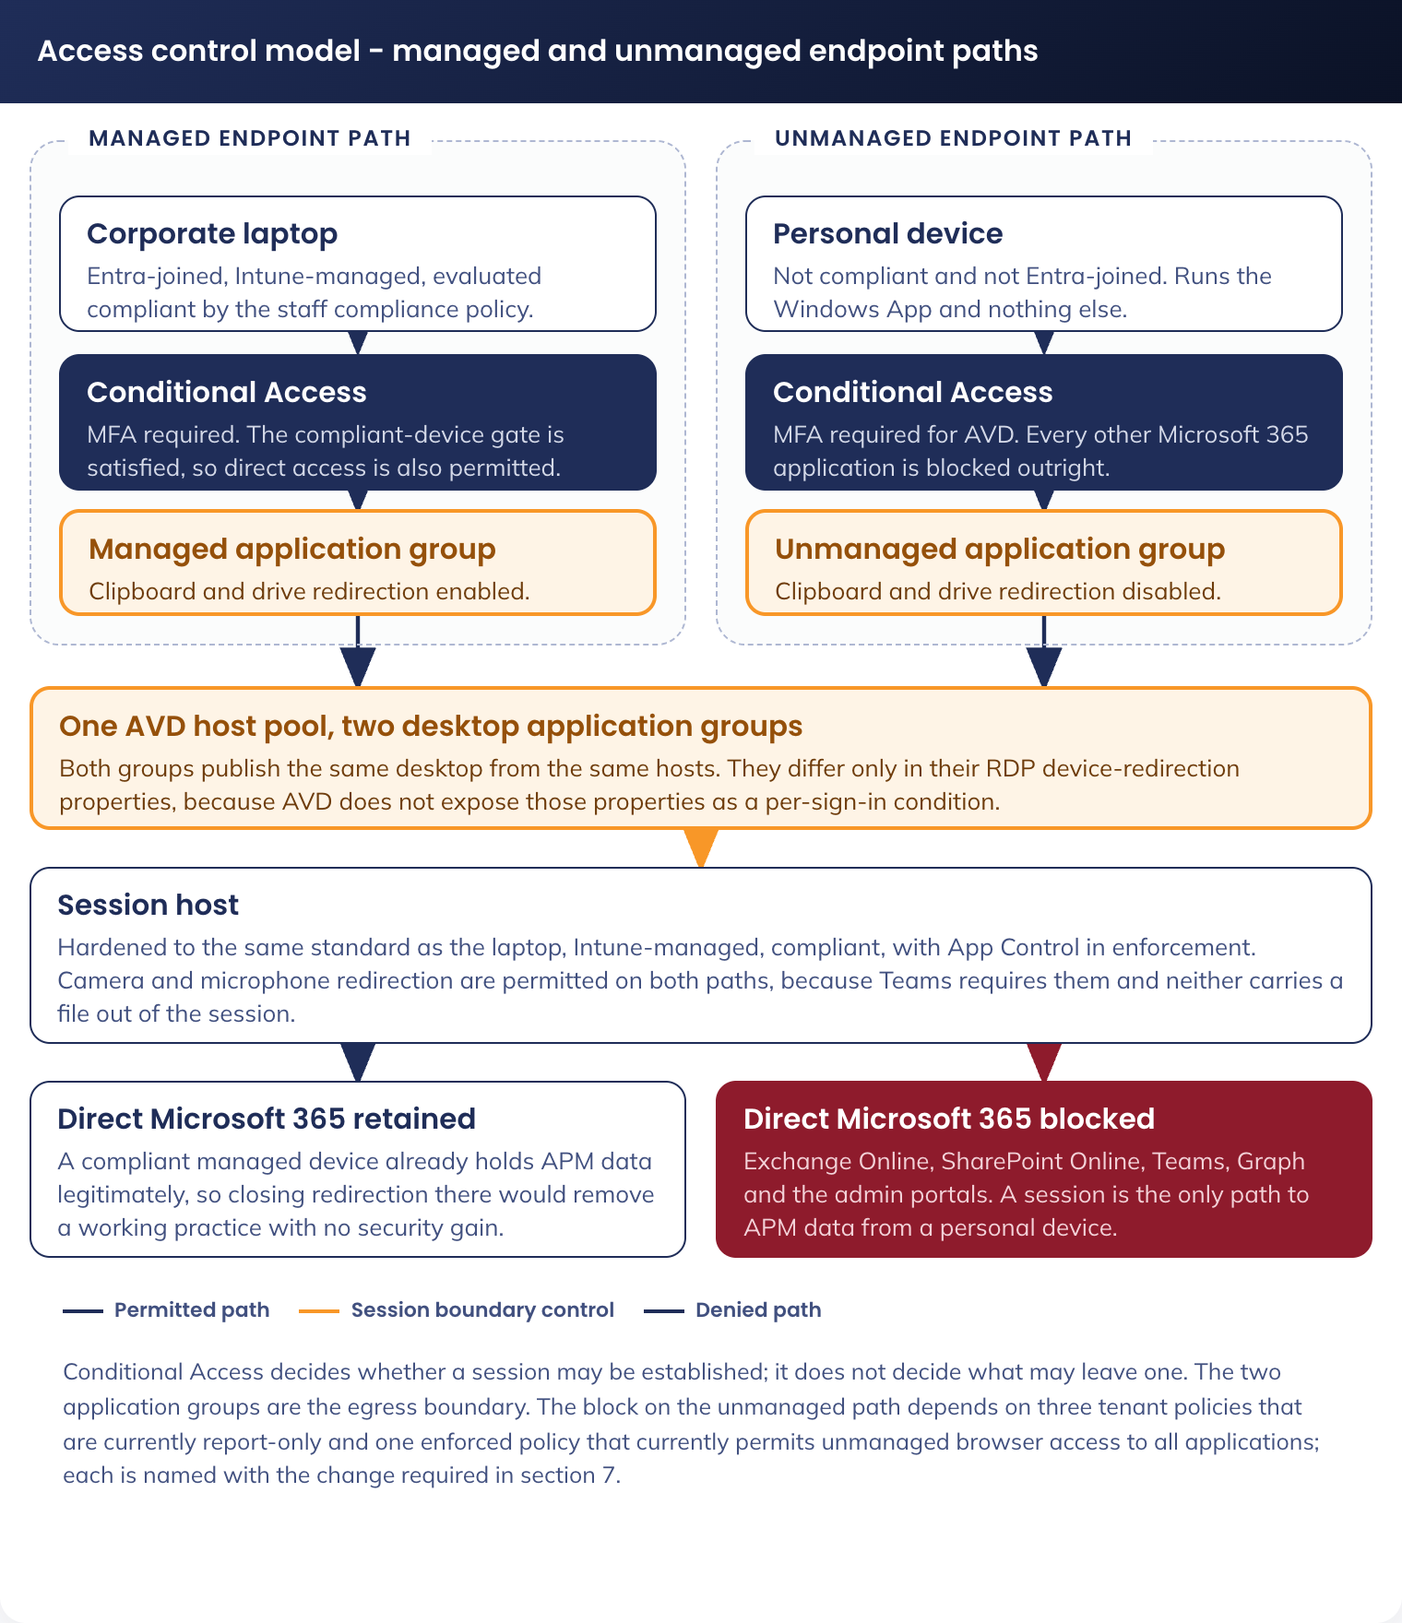
Figure 4. Access control model - managed and unmanaged endpoint paths
Device redirection as the data egress boundary. Conditional Access decides whether a session may be established. It does not decide what may leave the session, and AVD does not expose RDP properties as a per-sign-in condition. The boundary is therefore drawn with two desktop application groups on the same host pool, as DR-013 records.
RDP property | Managed endpoint group | Unmanaged endpoint group
Clipboard redirection | Enabled, both directions | Disabled
Drive redirection | Enabled | Disabled
USB device redirection | Disabled | Disabled
Printer redirection | Enabled | Disabled
Camera redirection | Enabled | Enabled, required for Teams
Microphone and audio capture | Enabled | Enabled, required for Teams
Audio playback to the endpoint | Enabled | Enabled
Smart card redirection | Enabled | Enabled
WebAuthn redirection | Enabled | Enabled, so a security key on the endpoint can satisfy authentication inside the session
Entra authentication to the session host | Enabled | Enabled

Camera and microphone are permitted on the unmanaged path deliberately: neither carries a file out of the session, and removing them would break the collaboration requirement without a corresponding security gain. Clipboard, drive and printer redirection are the three paths by which content leaves a session, and all three are closed on the unmanaged path.
Printing is delivered by that same redirection mechanism rather than by a print service (DR-019). This population is office and home-based staff on corporate endpoints, so the printers a user needs are already installed on their own device: at an APM site, including a participant site, the endpoint sits on the corporate network and holds the site queues; at home it holds the user's own printer. Redirection presents those queues inside the session. The session host itself never resolves or connects to a printer, so no hybrid connectivity, print server, connector or cloud print licence is introduced, and no firewall rule is added to 5.3.8. On the unmanaged path printer redirection is disabled, because a document printed from a personal device has left the session as surely as one copied to a local drive.
A user on a managed corporate device retains clipboard and drive redirection because that device is already entitled to hold APM data: it is Intune-managed, encrypted, and evaluated by the same compliance policy that gates its direct Microsoft 365 access. Closing redirection there would remove a working practice without changing what that user can legitimately do.
Session host hardening: SOE Hardening Standard alignment. The session host is a Windows 11 Enterprise endpoint and is governed by the same document as every other APM Windows device. It inherits the standard, and where a control cannot physically apply to a pooled multi-session virtual machine, the variation is named, compensated and given an owner. An RFFR assessor audits the variations, not the controls that applied, so each is stated with its compensating control.
Inherited unchanged. Every one of the eleven policy objects in the standard is assigned to the session host device group with no change to its content (DR-001).
The two Edge hardened exception variants share a row, and the App Control Audit and Enforced pair share a row, so the seven rows below cover all of them.
Policy | Controls | Relevance on a session host
`APM-W11-SEC-Baseline-P-1.2` and the Windows 11 security baseline it sits within | 594 | The bulk of the hardening: Credential Guard and virtualisation-based security (available because session hosts are Trusted Launch virtual machines with virtual TPM), LSA protection, SMB v1 disabled, NTLMv1 disabled, WDigest off, PowerShell 2.0 removed, User Account Control restrictions on network logon, and the screen saver and lock policy that governs an idle session
`APM-WIN-SEC-ASR-P-1.0`, attack surface reduction | 20 | Office child-process and executable-content blocks, obfuscated-script blocking, credential theft from LSASS blocked, PSExec and WMI process creation blocked, WMI persistence blocked, advanced ransomware protection, and vulnerable signed driver abuse blocked. All apply to a session host exactly as to a laptop
`APM-W11-SEC-Edge Baseline-P-1.2` | 25 | Password manager disabled, SmartScreen enforced, download restrictions, extension control. Applies unchanged, and is the reason no credential is written into the roaming profile
`APM-W11-SEC-Edge Dev Baseline-P-2.0` | 1 | Developer tools disabled. Session hosts are never in the developer exception group, so `APM-W11-SEC-Edge Dev Exception-P-2.0` does not reach this fleet
`APM-Edge-Hardened-Baseline-V1.0-Accessibility` and `-LastPass` | 25 each | Scoped exception variants of the Edge baseline. They reach an AVD user only if that user is already in the corresponding exception group on the laptop channel, so the exception follows the user rather than the channel
`APM-WIN-SEC-USB Baseline-P-1.0` | 16 | Deny all removable storage classes, and deny execute and write on CD, DVD, floppy, removable disk, tape and Windows Portable Devices. A pooled session host has no physical port, so this is defence in depth against a redirected volume; the effective control is the host pool property (DR-012)
App Control for Business, Audit and Enforced pair | 12 rule options | Enforced on session hosts, base policy v2026.03.27.0216 with 18 trusted signers, inherited without modification (DR-010). Script enforcement is disabled in the inherited policy, which is GAP-03 and is identical in both channels

Varied, with the reason and the compensating control. Six variations. Each is recorded as an accepted variation in the Standard User AVD RFFR Statement of Applicability, owned by APM Cyber Security.
Ref | Control varied | Why it cannot apply as written | Compensating control
SOE-01 | `Staff-Windows-Compliance-Policy`, the laptop compliance policy | It requires BitLocker, which a pooled multi-session host does not use, so an unmodified assignment would mark every session host non-compliant and, through Conditional Access, break the service | A separate multi-session compliance policy, specified below. It carries every other gate from the laptop policy and adds a minimum operating system version that the laptop policy does not enforce (GAP-04)
SOE-02 | `APM-W11-SEC-Bitlocker-P-1.1`, including additional authentication at startup | BitLocker is not used on a pooled session host, and a virtual machine that must boot unattended into a host pool cannot prompt anyone for a startup credential | Azure platform encryption on the managed disk and on the profile share, with platform-managed keys. The policy remains assigned and reports as not applicable, per DR-001. Recorded as a variation for RFFR rather than as an omission
SOE-03 | Removable-drive encryption, in the same BitLocker policy | There is no removable drive on a session host to encrypt, and drive redirection from an unmanaged endpoint is disabled, so no external volume is presented | Redirection closed on the unmanaged path (DR-013); removable storage classes denied at the operating system level in any case; attack surface reduction blocking untrusted processes from removable media
SOE-04 | Physical network adapter controls, including "minimize the number of simultaneous connections to the internet or a Windows domain" | A session host has one virtual network interface, no wireless adapter and no path to a second network. The laptop channel's business override on this setting has no equivalent effect here | Not required. The session host's single interface is governed by the route table and network security group in 5.3, which is a stronger control than an adapter policy
SOE-05 | "Allow location", which the laptop channel forces on as a business override | The location a session host reports is the Azure region, not the user's location, so the setting neither serves nor harms the business purpose it exists for on the laptop | The setting is inherited unchanged so the channels do not diverge in policy content. Its business consumers are told that AVD sessions report a datacentre location, so location-dependent workflows must use the laptop channel
SOE-06 | Remote Desktop Services disabled, as the baseline sets for a workstation | A session host exists to accept a Remote Desktop Protocol session, so the control that disables Remote Desktop Services cannot be applied to it | Access to the session host is only through the AVD reverse connect transport, brokered, with no inbound port open to the spoke (I-02, 5.3.7). Direct Remote Desktop Protocol from any network is not reachable. Session limits (DR-014) bound how long any session persists

Added, beyond the laptop standard. Five controls the laptop channel does not need.
Control | What it does
Multi-session compliance policy | The counterpart to `Staff-Windows-Compliance-Policy` for session hosts: Secure Boot required and virtual TPM required (both available on Trusted Launch virtual machines), firewall required, antivirus, antispyware, Defender antimalware and real-time protection required, security intelligence up to date required, and a minimum operating system version pinned. BitLocker is not evaluated, per SOE-02. This policy produces the compliant-device signal that Conditional Access consumes for the host
Profile container mount as a sign-in gate | FSLogix is configured to fail the sign-in if the profile container cannot mount, rather than falling back to a temporary local profile. Without this, a storage fault silently strands a user's data on a host that will be replaced
Session time limits | Idle disconnect and disconnected sign-out (DR-014). On a shared host these are a security control as well as a capacity control: they bound how long an unattended authenticated session exists
Device redirection properties | The two application groups in DR-013. This control has no laptop equivalent because a laptop has no session boundary to cross
Shared computer activation for Microsoft 365 Apps | Required for a multi-user host. Without it, activation binds to the first user on each host and subsequent users are refused

Web filtering and browser hardening. Browsing from a session is filtered by Zscaler Internet Access through the Client Connector in the image, in machine tunnel mode, using the existing APM category policy, and the traffic is inspected again by the hub firewall on its way out of the spoke (5.3.8). Browser hardening is delivered by the inherited Edge policies. The user's filtering experience is therefore the same in both channels, which is what the SOE consistency principle requires.
Endpoint detection and response. Defender for Endpoint is in the image and every session host onboards on provisioning. Because hosts are replaced monthly, the device inventory in Defender turns over on the same cycle, and an alert must be triaged against a host that may no longer exist. The mitigation is that user activity is attributable through the session and the profile container rather than through the host name, and Sentinel holds the correlated record (9.2).
Decommissioning. This design decommissions nothing. It adds a channel alongside the laptop SOE and retires no component of it. Where an individual user's laptop is later withdrawn as a consequence of adopting AVD, that is an endpoint lifecycle action under the existing asset process, not a change to this solution.
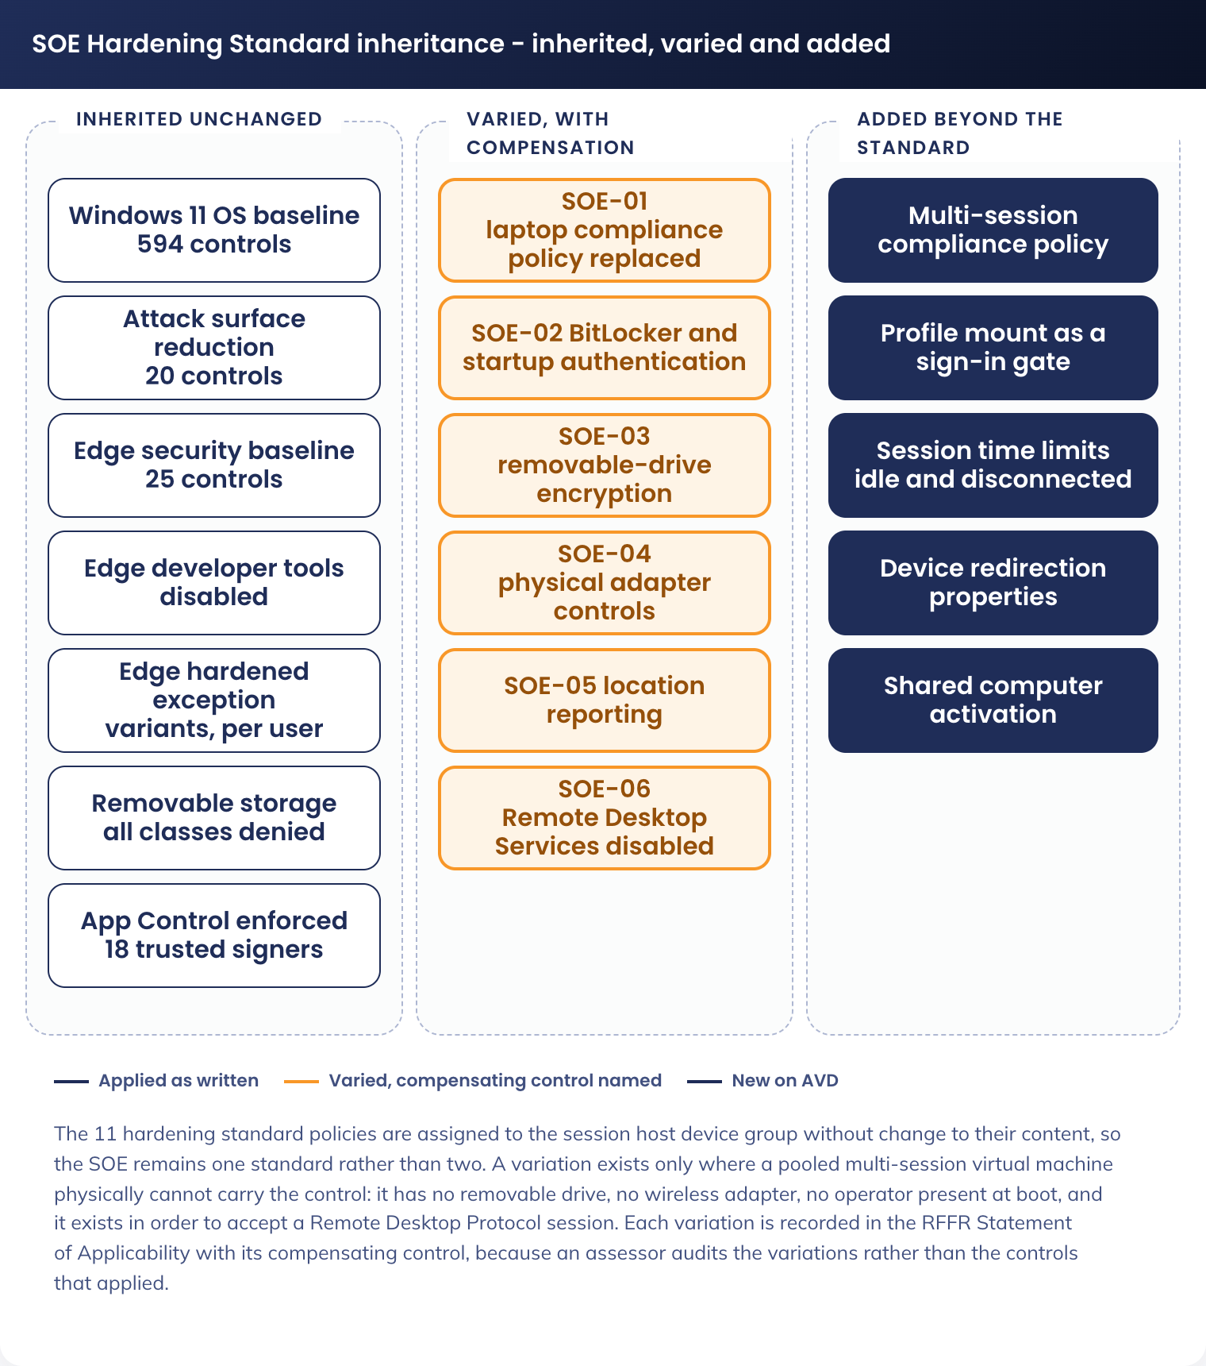
Figure 5. SOE Hardening Standard inheritance - inherited, varied and added
Risk register.
ID | Risk | Likelihood | Impact | Treatment | Owner
R-01 | An unmanaged device reaches Microsoft 365 directly, because the Conditional Access changes in this section are not made or are later reverted | Medium | High | The AVD-scoped block policy is enforced and owned by this design rather than depending on CA-200. Pilot exit requires the block to be demonstrated from a genuinely unmanaged device, not assumed. Conditional Access change control applies thereafter | APM Cyber Security
R-02 | A corporate policy or application assignment targeting All Devices or All Users lands on session hosts and breaks the host pool | Medium | High | Session hosts are in their own dynamic device group and the group is excluded from assignments that must not reach it. The pilot host group receives every change first, so a bad assignment is seen on one host before the fleet | Identity and Endpoint, with APM Cyber Security
R-03 | A bad image version is promoted and breaks sign-in across the pool | Low | High | Validation host pool with a fixed validation set before promotion; drain-mode rollout so no active session is interrupted; rollback by reimaging from the previous Compute Gallery version, tested during the pilot | Digital Operations
R-04 | Profile storage becomes unavailable or exhausts capacity, and users cannot sign in | Low | High | Sign-in fails closed by design rather than stranding data. Zone-redundant Premium storage, provisioned capacity monitored with an alert before exhaustion, and share snapshots for profile-level recovery | Digital Operations
R-05 | The hub firewall does not permit an endpoint the session host needs, so hosts cannot register or a workload fails inside the session | Medium | Medium | The named destination list in 5.3.8 is confirmed as configured before the first host is provisioned, not discovered during the pilot. The next-hop address for the route table is verified against the live estate (5.3.4, R-08) | APM Network Management with the AVD Build Engineer (Twiki Corp)
R-06 | Platform administration stops working in November 2026, when every management group role assignment in the landing zone expires with no recorded renewal process [CORPUS: Part1-Core-Architecture-As-Built.md] | Medium | High | Not a risk this design can treat: it is a platform open item affecting every workload in the estate. Raised so the dependency is visible, with the renewal process requested from the platform owner before the rollout window | Digital Transformation and Architecture
R-07 | Security log retention is 30 days in `auea-law-sec-001` against APM's 180-day non-functional requirement, so the evidence trail for an RFFR assessment or an investigation is shorter than the obligation [CORPUS: Part1-Core-Architecture-As-Built.md] | High | Medium | Diagnostic settings are configured to the operational workspace (90 days) as well as the security workspace, and the platform export to 180-day lifecycle storage covers operational logs. Closing the security workspace shortfall is a platform action owned outside this design | APM Cyber Security with the platform owner
R-08 | The route table next hop is wrong, because the as-built records a placeholder address and does not state the intended load balancer frontend IP | Medium | High | The live value is read from a deployed spoke route table and confirmed by Network Management before the first session host is provisioned. Marked `[UNKNOWN]` in 5.3.4 rather than assumed | APM Network Management
R-09 | A private DNS zone the design needs cannot be created, because policy denies private DNS zone creation outside the connectivity subscription | Medium | Medium | Zone requirements are raised with Network Management as a dependency during Phase 1 (9.1), not discovered at private endpoint creation. Three zones are named in 5.3.5 | APM Network Management
R-10 | Density assumptions are wrong and sessions per host must fall, raising cost per user materially above the business case | Medium | Medium | Pilot measures actual processor, memory and profile input/output per session against the baseline size, and the maximum session limit and virtual machine size are tuned before rollout rather than after | Digital Operations with Digital Transformation and Architecture
R-12 | A change proven in the test environment still fails in production, because Intune and Conditional Access are tenant-level and cannot be duplicated in a non-production tenant (Appendix B.1) | Medium | Medium | The test environment isolates the Azure, compute, network and storage planes completely. On the shared tenant planes, isolation is by assignment: T-ring policy twins targeted only at the test device group, and Conditional Access enforced against a test user group before the entitlement group. The production validation host pool is the final gate for the parts the test environment cannot reach | Digital Operations with APM Cyber Security
R-11 | A user cannot reach a session while travelling outside Australia, because the inherited location-based Conditional Access block applies | High | Low | Behaviour is inherited and intended. Communicated as an operational consequence, with the existing exception process for approved travel | APM Cyber Security

8. Service Availability and Disaster Recovery

8.1 Business Service Tiering
The Standard User SOE on AVD is classified Tier 2. An extended outage stops work for every member of staff whose only channel is AVD, which affects APM's ability to meet its service deed obligations, but alternate work modes exist: staff who also hold a corporate laptop continue working on the laptop channel throughout.
The classification is more stringent than the Participant Kiosk, where an outage degrades a self-service facility, and less stringent than a Tier 1 revenue or statutory reporting system, because a channel outage is not a data loss and does not stop the organisation. Tier 2 targets 99.9 per cent availability, a four-hour recovery time objective and a 24-hour recovery point objective. The recovery point objective applies to the profile container, since it is the only user data this solution stores; mail and documents are in Microsoft 365 and carry their own objectives.

8.2 Service Availability
Layer | Availability design
AVD control plane and gateway | Microsoft-managed service with its own service level agreement. A regional control plane incident prevents new sessions being brokered and does not disconnect established sessions. No APM control mitigates this; it is the residual risk in 8.1
Session host compute | Hosts spread across the availability zones available in Australia East. Loss of a zone removes a proportion of capacity, and auto-scale replaces the lost hosts from the image. No user data is lost because state is in the profile container
Profile storage | Azure Files Premium, zone-redundant in Australia East. A single-zone fault does not take profile storage offline
Host pool capacity | At least one available host held as buffer during business hours, and start-virtual-machine-on-connect enabled so a user outside scale-out hours starts a host rather than being refused
Egress path | Inherited hub firewall resilience: dual firewall sets behind load balancers in the hub [CORPUS: Part1-Core-Architecture-As-Built.md]. A hub firewall outage is an estate-wide platform incident
Detection | AVD Insights, Defender for Cloud, Intune compliance reporting and the Sentinel rules in 9.2, alerting to the Service Desk and to Digital Operations

8.2 Disaster recovery & Resilience
The architecture is recoverable because almost nothing in it is unique. A session host is disposable, the image is versioned, and the host pool can be rebuilt from the gallery. Five mechanisms carry recovery, in the order they would be used.
Mechanism | What it recovers
Image version rollback | A bad image. Reimaging from the previous Compute Gallery version through Nerdio is the fastest recovery in the design and is tested during the pilot rather than assumed
Host replacement | A failed or compromised session host. Nerdio provisions a replacement from the same image version. No user data is at stake
Profile share snapshots | A corrupted or accidentally cleared user profile. Snapshots run on a schedule with a defined retention, giving a per-user recovery point
Host pool rebuild | Loss of the host pool object or its configuration. The pool is rebuilt from the image and the configuration in the companion Technical Configuration Document, which is why that document is the recovery artefact for this layer
Channel fallback | An extended regional outage. Staff holding a corporate laptop continue on the laptop channel. Staff whose only channel is AVD stop work until service is restored. This is the accepted Tier 2 behaviour and is the single most important consequence for the business to acknowledge before rollout

Cross-region profile replication is not implemented in this version (DR-009 records the regional pattern as the recovery posture). The consequence is stated plainly: a regional failure is recovered by standing up the pattern in the second region, which is a deployment activity measured in hours to days, not an automatic failover. The Australia Southeast address allocation already exists, so the work is deployment rather than design.
One landing zone item bears on this section and is not resolved: the estate's disaster recovery posture is recorded as unreconciled, with a dual-region deployment as-built against a believed-ratified single-region multi-zone position that was never ingested [CORPUS: Part1-Core-Architecture-As-Built.md]. `[UNRECONCILED]` - this design's regional pattern is compatible with either, because it deploys to one region and holds an allocation in the other, but the platform position must be settled before a second region is funded.

9. Service Management

9.1 Service Management principles
Principle | Application to this service
Change control | Every change to the host pool, the image, the Intune policy set or the Conditional Access policies follows the existing APM change process. Image promotions and Conditional Access changes go to the Change Advisory Board because both can affect the whole user population at once
Nothing untested reaches production | Image changes are validated on the validation host pool against a fixed validation set. Intune policy changes reach the pilot host group before the fleet. Conditional Access changes are proven from a genuinely unmanaged device, not from a policy simulation
Two controls held back until the pilot passes | The enforced Conditional Access block on unmanaged access to non-AVD applications, and the opening of the AVD entitlement group beyond the pilot. Neither is applied to the general population until the pilot exit criteria are met
Runbooks before handover | Image build, host pool patching, capacity tuning, profile container lifecycle, profile recovery from snapshot, image rollback and host pool rebuild each have a runbook before the service transitions to Digital Operations
Incident response | The existing APM major incident process applies. Session host telemetry and Nerdio audit events are in Sentinel, so an AVD incident is investigated from the same place as any other
Capacity review | Concurrency, sessions per host and scale events are reviewed on a defined cycle, and auto-scale parameters and the maximum session limit are tuned against observed load rather than the design baseline

Implementation sequence. Five phases, in dependency order. Each phase's detailed steps and every setting are in the companion Technical Configuration Document.
Phase | Contents | Exit criterion
1. Foundation | Entra ID groups; session host device group; exclusion of the session host group from corporate assignments that must not reach it; the AVD-specific Intune profiles and the multi-session compliance policy; the two Conditional Access policies created in report-only; the Microsoft 365 E5 AVD user access right reconfirmed with SoftwareOne as a record check rather than a procurement action (A-01); and the network dependencies raised with Network Management: route table next hop (R-08), private DNS zones (R-09) and the named egress destinations (5.3.8) | Groups exist, policies exist, and the network dependencies have a confirmed answer rather than an assumption
2. Platform | Subnets, route table, network security groups and private endpoints in the existing spoke; the profile storage account and share with Entra Kerberos; the Compute Gallery and image definition; the App Attach storage; the host pool, workspace and two application groups in Nerdio; auto-scale configuration | A session host provisions, joins Entra ID, enrols in Intune, reports compliant, and mounts a profile container
3. Image and validation | Golden image version 1 built and captured; validation host pool reimaged; the validation set run end to end | Sign-in, profile mount, Office activation, a Teams call, application launch, Zscaler-filtered browsing and clean sign-out all pass on the validation pool
4. Pilot | A controlled pilot across mixed personas, on both endpoint contexts. Conditional Access moved to enforced for the pilot group. Density, sizing, session limits and profile sizing measured and tuned. Redirection boundary tested from an unmanaged device. Image rollback rehearsed | Pilot exit criteria met on sign-in time, session stability, the unmanaged-device block, the redirection boundary and rollback. GAP-01 has a decision
5. Rollout and handover | Entitlement opened progressively; Windows App published to corporate endpoints and instructions issued for personal devices; monitoring and alerting confirmed with Service Desk routing; runbooks handed to Digital Operations; RFFR alignment review with the Compliance Manager; first capacity review scheduled | Service is in production with Digital Operations accountable, and the Statement of Applicability records the six variations in 7

9.2 Monitoring, Logging, Reporting and Alerting
Telemetry lands in the two Australia East workspaces the landing zone provides, and Microsoft Sentinel in the security subscription is the correlation and evidence layer [CORPUS: Part1-Core-Architecture-As-Built.md].
Source | Mechanism | Signal and alerting
AVD host pool, workspace and application groups | Diagnostic settings to `auea-law-mgmt-operation-001` | Connection events, session host availability, brokering errors and connection failure reasons. Alert on a sustained rise in connection failures, which is the first symptom of a broker, network or profile fault
Session host operating system | Azure Monitor agent with data collection rules | Performance counters for density tuning, Windows security events, and App Control events. Performance data is the input to the capacity review; security events go to the security workspace
FSLogix | Agent event log collection through the Azure Monitor agent | Container mount success and failure, and mount duration. Alert on any mount failure, because a mount failure is a failed sign-in for that user under the fail-closed design
Microsoft Defender for Endpoint | Existing Defender tenancy | Endpoint alerts, attack surface reduction events, App Control blocks and vulnerability exposure. Alert to APM Cyber Security at medium severity and above, matching the laptop channel
Microsoft Intune | Native Intune reporting | Compliance state, profile assignment success and failure, and application install state per session host. A profile failure across newly provisioned hosts is the detection for a broken image or a bad assignment (R-02)
Microsoft Entra ID | Sign-in and audit logs | Conditional Access evaluation outcome per AVD sign-in, blocked unmanaged-device attempts, and device compliance state. The blocked-attempt count is the ongoing evidence that R-01 is being controlled
Nerdio Manager for Enterprise | Nerdio audit log and diagnostic export to the Log Analytics workspaces (DR-016) | Host pool operations, auto-scale actions, image lifecycle events and administrator actions. This is the audit record of who changed the host pool, and it is the reason Nerdio operations are attributable
Azure Files, profile share | Diagnostic settings | SMB transactions, throttling and provisioned capacity consumed. Alert before capacity exhaustion rather than on failure (R-04)
Network security groups and the spoke | Flow logs, 14-day retention in the platform flow log storage account [CORPUS: Part1-Core-Architecture-As-Built.md] | Allowed and denied flows from the session host subnet. The evidence that egress is constrained as 5.3.7 specifies
Hub Palo Alto firewalls | Existing chain: firewalls to Panorama, then syslog forward to Microsoft Sentinel [CORPUS: Part1-Core-Architecture-As-Built.md] | Egress policy decisions, threat and URL events for AVD spoke traffic. Inherited; this design adds no forwarding
Microsoft Sentinel | The aggregate of the above, in the security subscription | Correlation across identity, endpoint, network and platform, and the source of RFFR evidence. Retention constraint is R-07

Two reporting outputs are produced for the service rather than for an incident. A monthly capacity and cost report covering concurrency, sessions per host, scale events and consumption, which feeds the capacity review in 9.1. And a compliance report covering session host compliance state, App Control events and Conditional Access blocked attempts, which is the standing evidence set for the RFFR alignment review.

Appendix A: Terms & Abbreviations
Term | Definition
APM | Advanced Personnel Management
ASD | Australian Signals Directorate, publisher of the Information Security Manual and Australian government hardening guidance
ASR | Attack surface reduction, a Microsoft Defender control set
AVD | Azure Virtual Desktop
App Attach | AVD capability that mounts an application package to a session on demand rather than installing it in the image
App Control for Business | Microsoft application control technology, formerly Windows Defender Application Control
AUEA / AUSE | Australia East and Australia Southeast, the landing zone region tokens
BYOD | Bring your own device: a personal device APM does not manage
CIDR | Classless inter-domain routing notation for an address range
Compute Gallery | Azure service holding versioned virtual machine image definitions with regional replication
Conditional Access | Microsoft Entra ID policy engine that evaluates each sign-in and grants, blocks or constrains it
DEWR | Department of Employment and Workplace Relations
Drain mode | Host pool state in which a session host accepts no new session, used to empty a host before replacing it
EDR | Endpoint detection and response
Entra Kerberos | Microsoft Entra ID issuing Kerberos tickets for Azure Files, removing the Active Directory Domain Services dependency
ESLZ | Enterprise-Scale Landing Zone, the APM Azure platform architecture
FSLogix | Microsoft profile container technology that holds a user's Windows profile in a virtual disk
ISM | Information Security Manual (ASD)
LAW | Log Analytics workspace
Multi-session | Windows 11 Enterprise edition permitting concurrent interactive sessions on one operating system instance
MSIX | Microsoft application package format used by App Attach
Nerdio Manager for Enterprise | Orchestration and management layer for AVD host pools, images and auto-scale
NSG | Network security group, an Azure subnet or interface level packet filter
NVA | Network virtual appliance, here the hub Palo Alto VM-Series firewalls
PIM | Privileged Identity Management, Entra ID just-in-time role activation
Private endpoint | A private IP address in a virtual network that reaches an Azure service without traversing the internet
Reverse connect | AVD transport in which both endpoint and session host connect outbound to a Microsoft-managed gateway, so no inbound port is opened
RFFR | Right Fit For Risk, the DEWR cyber security accreditation framework, based on ISO/IEC 27001 and the ASD ISM
RPO / RTO | Recovery point objective and recovery time objective
SOE | Standard Operating Environment, APM's managed device build and its hardening standard
Shortpath | AVD transport optimisation using UDP where the network permits it
Trusted Launch | Azure virtual machine security type providing Secure Boot and a virtual TPM
UDR | User-defined route, the Azure routing construct that forces spoke traffic to the hub firewall
Windows App | Microsoft client application used to reach an AVD session from an endpoint
Zscaler Internet Access | Cloud web filtering and threat protection service used by APM

Appendix B: Test Environment

B.1 Purpose, and what it cannot prove
A non-production environment is built before any production object is created, so the solution can be assembled, broken and corrected without a production user, a production policy or a production network object being touched. It is where the golden image is built, where a new Intune profile is first applied, where the redirection boundary and the unmanaged-device block are first exercised, and where image rollback is rehearsed rather than assumed.
Three planes are fully isolated, because they are subscription-scoped: Azure compute, network and storage. A test session host cannot reach the production profile share, cannot use the production route table, and cannot be affected by a change to a production network security group.
Two planes cannot be isolated, and stating this plainly is the point of this appendix. Microsoft Intune and Microsoft Entra Conditional Access are tenant-level services: there is one Intune tenant and one Conditional Access policy set, shared with production and with the laptop fleet. Isolation on those planes is by assignment, not by boundary. The hub Palo Alto firewalls and Microsoft Sentinel are also shared platform services. The consequence is carried as R-12: a change proven in the test environment is not thereby proven in production, and the production validation host pool (5.4.2) is the gate for what the test environment cannot reach.

B.2 Placement
The environment is deployed into the landing zone's existing Dev Controlled subscription and virtual network rather than into a new spoke or into the production AVD spoke (DR-018).
Item | Value | Note
Subscription | `aus-sub-dev-controlled-001` | Exists. Dev environment, Controlled archetype, so the RFFR control set still applies and a test result is meaningful for production [CORPUS: Part3-IPAM-Policy-Standards.md]
Virtual network | `auea-vnet-dev-ctrl-001` | Exists, `10.40.24.0/23`, already peered to `auea-vnet-connectivity-001` [CORPUS: Part3-IPAM-Policy-Standards.md]
Reserved additional CIDRs | `10.40.26.0/23`, `10.40.28.0/23`, `10.40.30.0/23` | Held for this virtual network by the address plan [CORPUS: Part3-IPAM-Policy-Standards.md]
Management group | AUS-MG-CONTROLLED, under AUS-MG-REGION | Same archetype as the production AVD subscription, which is what makes the two environments comparable [CORPUS: Part1-Core-Architecture-As-Built.md]
Egress | Inherited: route table with `0.0.0.0/0` to the hub Palo Alto firewall, exactly as production | The test environment therefore exercises the same firewall policy path, though not the same rule set, since firewall rules are written per source prefix

B.3 Subnet allocation
The Dev Controlled virtual network is shared with other non-production workloads, so this design takes a slice from the upper half of the range and the free space is confirmed against the live virtual network before build.
Subnet | CIDR | Usable | Purpose
`auea-snet-dev-ctrl-avdhosts-001` | `10.40.25.0/26` | 59 | Test session host interfaces. Sized for a test pool plus concurrent reimaging, not for the production fleet
`auea-snet-dev-ctrl-avdpe-001` | `10.40.25.64/28` | 11 | Private endpoints for the test profile share and the test App Attach share
`auea-snet-dev-ctrl-avdbuild-001` | `10.40.25.80/28` | 11 | Image build. This is where the golden image is assembled (5.4.1) and the only subnet in either environment where routine broad package download is permitted
Unallocated | `10.40.25.96/27`, `10.40.25.128/25` | - | Left free in the shared virtual network

Free space in `10.40.24.0/23` is confirmed with APM Network Management before these subnets are created. If the range above is already in use, the allocation moves within the same virtual network and no other part of this appendix changes.

B.4 Azure objects
Names follow the same standards as production (5.1.5), with the environment token `dev` and the security domain `ctrl`, so a test object is never mistaken for a production one.
Object | Test name | Production counterpart
Route table | `auea-rt-dev-ctrl-001` | `auea-rt-avd-ctrl-001`. Separate table, so a routing change in test cannot reach production
Network security groups | `auea-nsg-dev-ctrl-avdhosts-001`, `-avdpe-001`, `-avdbuild-001` | The three production groups in 5.3.7. The test baseline starts as a copy and diverges only while a rule is being proven
Host pool | `auea-avdhp-dev-ctrl-staff-001` | `auea-avdhp-avd-ctrl-staff-001`
Workspace | `auea-avdws-dev-ctrl-staff-001` | `auea-avdws-avd-ctrl-staff-001`
Application groups | `auea-avdag-dev-ctrl-staff-managed-001`, `auea-avdag-dev-ctrl-staff-unmanaged-001` | Both production groups. Two are required in test, because the redirection boundary is one of the things being proven
Profile storage | `aestdcfslogix001` | `aestacfslogix001`. A separate storage account, so no test action can touch a production profile
App Attach storage | `aestdcappattach001` | `aestacappattach001`
Session host virtual machines | Prefix `aevmdcstd` | Prefix `aevmacstd`. The prefixes differ, which is what allows the two dynamic device groups to be mutually exclusive
Compute Gallery | Shared: `aegalacstaff001` in the production AVD subscription | Deliberately not duplicated. The test environment reads the same gallery so the artefact validated in test is the identical image version promoted to production, byte for byte. This requires a reader role grant on the gallery to the test subscription's provisioning identity, which is the one cross-environment permission this appendix creates

B.5 Intune, Entra ID and Conditional Access
These are the shared planes. Isolation is by assignment and by ring, and the objects below are the mechanism.
Object | Name | Purpose
Test session host device group | `sg-dyn-dvc-avd-session-hosts-test` | Dynamic, matched on the `aevmdcstd` prefix. Mutually exclusive with the production group, which matches `aevmacstd`
Test user group | `sg-stc-usr-avd-standard-user-test` | The test population: the project team and a small number of nominated business testers
Test desktop-assignment groups | `sg-stc-usr-avd-desktop-managed-test`, `sg-stc-usr-avd-desktop-unmanaged-test` | So one tester can hold each posture and the boundary can be tested from both sides at once
AVD profile twins | `AVD-W11-CFG-FSLogix Profile-T-1.0`, `AVD-W11-CFG-Session Time Limits-T-1.0`, `AVD-W11-CFG-Multi-Session Host-T-1.0` | T ring, per the Intune schema, assigned only to the test device group. A change is made here first and copied into the P-ring object once proven
Compliance policy twin | `AVD-W11-COM-Session Host-T-1.0` | As above. This is what proves the compliance policy marks a session host compliant before the production policy is created
Hardening standard policies | The 11 existing policies, unchanged | The test device group is added to their assignment scope as well, because inheritance (DR-001) is itself one of the things being proven, including which controls report as not applicable
Conditional Access | `CA-202` and `CA-210` (5.1.5) | Created once, not duplicated. Scoped first to the test user group in report-only, then enforced against the test user group only, then extended to the entitlement group at rollout. Report-only proves evaluation; it does not prove a block, so enforcement against the test group is a required step and not an optional one

B.6 What the test environment must prove
Each test has a pass criterion that is objectively true or false. All twelve pass before the production build begins, and the set is re-run in the test environment for every subsequent image version and every policy change.
ID | Test | Pass criterion
T-01 | Provision a session host from the shared gallery image | The host joins Entra ID, enrols in Intune, appears in the test device group and reports compliant, with no manual step
T-02 | Apply the 11 inherited hardening policies | All 11 report as applied. The set of controls reporting not applicable matches the six variations in 7 and contains nothing else
T-03 | Sign in a test user | The profile container is created and mounted, and the desktop presents the published application set
T-04 | Remove the test user's permission on the profile share, then sign in | Sign-in fails. No temporary profile is created and no user data is written to the host. This is the fail-closed behaviour in 7 and it is proven by fault injection, not by reading the setting
T-05 | Sign in a second user concurrently to the same host | Microsoft 365 Apps activate for both users through shared computer activation, and neither session is refused
T-06 | Place a Teams call | The call reports as optimised, and processor use on the session host stays at idle levels during the call, showing media is handled by the endpoint
T-07 | From the managed desktop, copy text and a file into and out of the session | Clipboard and drive redirection both succeed
T-08 | From the unmanaged desktop, attempt the same | Clipboard and drive redirection both fail. Camera and microphone still work
T-09 | From a device that is neither compliant nor Entra-joined, attempt Outlook on the web, SharePoint, Teams web and Graph | All are blocked by `CA-210`. The Windows App to AVD still succeeds with multi-factor authentication under `CA-202`
T-10 | Reach a destination not on the named egress list from a session host, then a destination on it | The first is denied at the hub firewall and the denial is visible in the firewall log; the second succeeds. This proves the egress model rather than assuming it
T-11 | Run an unsigned test binary | App Control blocks execution, and the block appears in Defender for Endpoint
T-12 | Leave the pool idle past the session limits, then trigger scale-in | An idle session disconnects at 1 hour, a disconnected session signs out at 4 hours, the profile container dismounts, and the emptied host is removed by auto-scale
T-13 | Reimage a host to the previous gallery image version | The host returns to service on the previous version and a user signs in successfully. This is the rollback control in 8.2 and it is rehearsed here
T-14 | Check the telemetry destinations | Host pool connection events, session host events, FSLogix mount events and Nerdio audit events are all queryable in the workspaces named in 9.2

T-04, T-08, T-09, T-10 and T-13 are the tests that prove a control rather than a feature. If time is constrained, they are the last to be cut, not the first.

B.7 Cost control and lifecycle
Aspect | Position
Running cost | The test host pool scales to a single host outside test windows and to zero overnight, using the same Nerdio auto-scale mechanism as production. Premium profile storage is provisioned at the minimum size the tier permits, because the test population is small
Retention after go-live | The environment is retained permanently, not torn down. It is where every subsequent image version, Intune policy change, network rule change and Conditional Access change is proven before it reaches the production validation pool (9.1)
Ownership | Digital Operations after handover, with the AVD Build Engineer (Twiki Corp) during the build phases
Data | No production data. Test users sign in with their own APM identities, so mail and documents reached from a test session are real. The test profile share therefore holds real cached corporate data and is protected to the same standard as production, which is why the environment sits in a Controlled subscription rather than a Standard one

B.8 Promotion path
A change moves in one direction through four gates, and cannot skip one.
1. Made in the test environment: a new image version, a T-ring Intune profile, a network security group or firewall rule, or a Conditional Access change scoped to the test user group
2. Proven in the test environment against the applicable tests in B.6
3. Applied to the production pilot ring: the P-ring policy object assigned to `sg-stc-dvc-avd-session-hosts-ring1`, or the new image version on the production validation host pool
4. Promoted to the production host pool by drain-mode reimaging or by extending the policy assignment to `sg-dyn-dvc-avd-session-hosts`
The one exception is a Conditional Access change, which has no image and no ring: it moves from report-only, to enforced against the test user group, to enforced against the entitlement group, and each step is a separate change record.

